Table of Contents
1---INTRODUCTION TO BLACKHOLES 2
2---FORMATION OF BLACKHOLES 10
-TYPES OF BLACKHOLES BASED ON-“ORIGIN” 13
-INTERMEDIATE MASS BLACK HOLES 29
-PRIMORDIAL BLACK HOLES (HYPOTHETICAL) 33
4---STRUCTURE & PROPERTIES 37
-EVENT HORIZON & SINGULARITY 37
-SCHWARZSCHILD & KERR BLACK HOLES 46
-HAWKING RADIATION & EVAPORATION 54
-ACCRETION DISKS & RELATIVISTIC JETS 58
5---EFFECTS ON SURROUNDING SPACE 64
-IMPACT ON STARS, PLANETS & GALAXIES 72
-TIME DILATION NEAR BLACK HOLES 80
6---OBSERVATIONAL EVIDENCE 89
-FAMOUS BLACKHOLES 97
7---BLACK HOLES IN THEORIES OF PHYSICS 113
-QUANTUM MECHANICS & THE BLACK HOLE INFORMATION PARADOX 122
-ROLE OF BLACK HOLES IN SPACE-TIME STRUCTURE 131
-THEIR ROLE IN GALAXY FORMATION 151
-DARK MATTER & BLACKHOLES- 159
9---CAN BLACK HOLES BE HARNESSED FOR ENERGY? 168
-WORMHOLES & SPACE TRAVEL THEORIES 175
-UPCOMING BLACK HOLE STUDIES & MISSIONS 185
10---CONCLUSION………………………………………………………..196
-SUMMARY OF KEYPOINTS…………………………………….196
-WHY DOES BLACK HOLE RESEARCH MATTER…………204
-FUTURE IMPLICATIONS FOR SPACE AND
SCIENCE EXPLORATION………………………………………….211
1---INTRODUCTION TO BLACKHOLES
-WHAT ARE Black Holes ?
Black holes are among the most mysterious cosmic objects, much studied but not fully understood. These objects aren’t really holes. They’re huge concentrations of matter packed into very tiny spaces. A black hole is so dense that gravity just beneath its surface, the event horizon, is strong enough that nothing – not even light – can escape. The event horizon isn’t a surface like Earth’s or even the Sun’s. It’s a boundary that contains all the matter that makes up the black hole.
There is much we don’t know about black holes, like what matter looks like inside their event horizons. However, there is a lot that scientists do know about black holes.
…………………………………. -HISTORY OF BLACK HOLE DISCOVERY
The history of black hole discovery is a fascinating journey blending physics, astronomy, and mathematics over centuries. Here's a timeline of major milestones:

18th–19th Century: Theoretical Origins
- 1784 – John Michell: An English natural philosopher, Michell proposed the idea of “dark stars” — objects so massive that not even light could escape their gravity. This was based on Newtonian mechanics.
- 1796 – Pierre-Simon Laplace: A French mathematician who independently suggested similar ideas in his work Exposition du Système du Monde.

Early 20th Century: General Relativity
- 1915 – Albert Einstein: Published the theory of General Relativity, laying the foundation for understanding gravity as the curvature of spacetime.
- 1916 – Karl Schwarzschild: Solved Einstein's equations to describe a non-rotating spherical mass — the Schwarzschild radius, which defines the size of a non-rotating black hole.
- 1930 – Subrahmanyan Chandrasekhar: Showed that white dwarfs above a certain mass (the Chandrasekhar limit, ~1.4 solar masses) cannot remain stable — a step toward the concept of neutron stars and black holes.

1939 – Oppenheimer and Snyder
- They proposed that massive stars could collapse under their own gravity after exhausting nuclear fuel, forming what we now call black holes. Their work wasn’t taken seriously at the time.

1960s–1970s: Black Holes Become Real
- 1963 – Roy Kerr: Found a solution for rotating black holes, called Kerr black holes.
- 1964 – Discovery of quasars: Extremely energetic galactic cores hinted at massive compact objects — likely black holes.
- 1967 – Term "black hole" coined: John Archibald Wheeler popularized the term.
- 1971 – Cygnus X-1: First strong black hole candidate discovered through X-ray emissions and companion star analysis.
- 1974 – Hawking radiation: Stephen Hawking showed black holes can emit radiation and eventually evaporate.

21st Century: Direct Observations
- 2015 – LIGO detects gravitational waves: First observation of black holes merging, confirming key predictions of general relativity.
- 2019 – First image of a black hole: Event Horizon Telescope released an image of the black hole in the galaxy M87, showing the shadow of its event horizon.
- 2022 – Image of Sagittarius A*: The supermassive black hole at the centre of our Milky Way was imaged, confirming it’s indeed a black hole.
-IMPORTANCE OF STUDYING BLACK
HOLES
Black holes are key to testing Einstein’s theory of general relativity under extreme gravity. They help us understand the role of gravity in shaping the universe. Studying supermassive black holes reveals how galaxies form and evolve. They offer insights into the behaviour of matter and energy in extreme conditions. Black holes are sources of gravitational waves, helping us observe cosmic events. They raise important questions about the nature of space, time, and information.
Observations of black holes improve our understanding of high-energy astrophysics. They may hold clues to unifying quantum mechanics and gravity. Black hole research drives advances in imaging, computing, and data analysis. Overall, they are central to answering some of the deepest questions in physics and cosmology. Black holes help trace the life cycles of stars, from birth to collapse. They provide evidence for the existence of dark matter and dark energy indirectly. Studying black hole jets explains how energy is transferred across galaxies. They help scientists understand cosmic phenomena like quasars and gamma-ray bursts. Black holes challenge classical physics, encouraging the development of new theories. Their study supports the search for a Theory of Everything in physics. They reveal how extreme magnetic fields and plasma behave in space. Black holes influence the dynamics of stars and planetary systems nearby. They help refine models of the early universe and cosmic background radiation. Research on black holes inspires curiosity and fuels public interest in space science.
……………………………………………………………………………………………

2---FORMATION OF BLACKHOLES
-stellar evolution & blackhole formation
Stars begin their life in vast clouds of gas and dust called nebulae. Under the force of gravity, parts of these clouds collapse to form a dense core that heats up until nuclear fusion ignites, marking the birth of a star. During the main sequence stage, the star fuses hydrogen into helium in its core, producing energy and maintaining a balance between gravitational collapse and internal pressure. This stage lasts for millions to billions of years, depending on the star’s mass. Once the hydrogen fuel runs out, the core contracts and the outer layers expand, forming a red giant or, in the case of more massive stars, a red supergiant.
In massive stars, fusion continues beyond helium, creating heavier and heavier elements in layers, like an onion. Eventually, iron forms in the core, but iron cannot undergo fusion to produce energy. Without outward pressure from fusion, the core collapses rapidly under gravity. This collapse leads to a catastrophic supernova explosion, where the outer layers are ejected into space, enriching the galaxy with heavy elements. The core that remains determines the star's fate—if it’s below about 2.5 solar masses, it becomes a neutron star; if it’s more massive, the core collapses completely to form a black hole.
A black hole is an object with an extremely strong gravitational field from which nothing, not even light, can escape. The point of no return around a black hole is known as the event horizon, and at its centre lies a singularity where density is thought to be infinite. Black holes formed from stellar evolution are called stellar-mass black holes. These cosmic objects are crucial in understanding high-energy astrophysics, galaxy formation, and the behaviour of matter under extreme conditions. Their formation marks one of the most dramatic and fascinating ends to a star's life.
The study of black hole formation and stellar evolution provides vital insights into the life cycles of stars, the structure of galaxies, and the fundamental forces of nature. It also plays a key role in our understanding of the universe’s past and future. For instance, the formation of supermassive black holes in the centres of galaxies may have influenced the development of galaxies themselves. By studying the remnants of massive stars, scientists gain a deeper understanding of the extreme environments where general relativity and quantum mechanics intersect.
------------------------------------------

-TYPES OF BLACKHOLES BASED ON-“ORIGIN”
Black holes can be classified into several types based on their origin. The three main categories are stellar-mass black holes, intermediate-mass black holes, and supermassive black holes. Here’s a breakdown of each:
- Stellar-Mass Black Holes:
  - These black holes form from the collapse of massive stars, typically those with at least 20 times the mass of the Sun.
  - When such stars reach the end of their life cycle and undergo a supernova explosion, the core that remains may collapse into a black hole.
  - Stellar-mass black holes generally have masses ranging from about 3 to 10 solar masses.
  - These are the most common type of black holes and are often detected through their interactions with companion stars or their effects on nearby matter.
- Intermediate-Mass Black Holes:
  - These black holes are hypothesized to exist between stellar-mass and supermassive black holes in terms of mass.
  - They typically have masses ranging from about 100 to 1000 solar masses.
  - Intermediate-mass black holes may form in star clusters through the merging of stellar-mass black holes or through the collapse of massive star clusters.
  - While direct evidence for these black holes is still limited, they are thought to play a key role in the formation of supermassive black holes.
- Supermassive Black Holes:
  - Supermassive black holes are found at the centres of most large galaxies, including our Milky Way.
  - They have masses ranging from millions to billions of solar masses.
  - The exact origin of supermassive black holes is still debated, but they may have formed from the merging of smaller black holes, the accretion of massive amounts of gas, or the collapse of massive gas clouds early in the universe’s history.
  - These black holes are essential for understanding the dynamics and evolution of galaxies, as they influence star formation and the overall behaviour of the galaxy.
Each type of black hole plays a unique role in our understanding of astrophysics and cosmology, and they are the subject of active research to uncover their origins and behaviours.

------------------------------------------
-ROLE OF SUPERNOVAE & NEUTRON STARS
Supernovae and neutron stars are both key components of stellar evolution and cosmic recycling. They represent some of the most dramatic and energetic events in the universe, and they play essential roles in the creation of elements, the formation of compact objects, and the evolution of galaxies. Understanding their roles helps scientists uncover the life cycles of stars and the broader dynamics of the cosmos.
A supernova is a powerful explosion that occurs when a massive star reaches the end of its life. This happens after the star has exhausted its nuclear fuel, especially when fusion in the core stops producing enough pressure to counteract the force of gravity. As a result, the core collapses suddenly, and the outer layers are violently expelled into space. This event releases an enormous amount of energy—sometimes outshining entire galaxies for a short time—and is one of the most luminous phenomena in the universe. Supernovae are classified into two main types: Type I, which usually involves white dwarfs in binary systems, and Type II, which result from the gravitational collapse of massive stars.
One of the most important roles of supernovae is element formation and distribution. Elements heavier than iron, such as gold, silver, and uranium, cannot be formed through regular stellar fusion. Instead, they are created during the intense heat and pressure of a supernova explosion through a process called nucleosynthesis. These elements are then ejected into space, enriching the interstellar medium. Over time, this material becomes part of new stars, planets, and even living organisms. In this way, supernovae contribute to the ongoing chemical evolution of the universe and play a fundamental role in the creation of the elements essential for life.
Supernovae also influence their surroundings in powerful ways. The shock waves from a supernova can compress nearby clouds of gas and dust, triggering the formation of new stars. This process helps drive stellar birth in galaxies and can affect the structure of the interstellar medium. Additionally, supernovae provide observational evidence for studying distant parts of the universe. Certain types, such as Type la supernovae, are used as "standard candles" to measure cosmic distances and the expansion of the universe. This has been crucial in understanding dark energy and the accelerating expansion of space.
If the core remnant left behind after a supernova is between about 1.4 and 3 solar masses, it becomes a neutron star. A neutron star is an incredibly dense object composed mostly of neutrons, with a diameter of just about 20 kilometres but a mass greater than that of the Sun. The gravity on a neutron star is so strong that it compresses atoms, crushing protons and electrons together to form neutrons. These stars rotate rapidly and often emit beams of electromagnetic radiation from their magnetic poles. When these beams sweep past Earth, we detect them as pulsars.
Neutron stars are important in astrophysics because they serve as laboratories for studying extreme physics—such as ultra-strong magnetic fields, relativistic gravity, and the behaviour of matter at nuclear densities. They help scientists explore the limits of matter and energy and provide insights into phenomena like gravitational waves, which are produced when two neutron stars collide or merge. These collisions also create heavy elements and produce detectable electromagnetic signals, allowing astronomers to observe the same event in multiple ways (multi-messenger astronomy).
In conclusion, supernovae and neutron stars play essential roles in the life and death of stars, the formation of elements, and the structure of the universe. Supernovae recycle stellar material and distribute it into space, making future star and planet formation possible. Neutron stars, as remnants of these explosions, offer valuable opportunities to study the universe under extreme conditions. Together, they form an integral part of the cosmic cycle and our understanding of how the universe evolves.
3---TYPES OF BLACK HOLES
-stellar mass black holes
Stellar-mass black holes are one of the most common types of black holes found in the universe. They form from the gravitational collapse of massive stars at the end of their life cycles. When a star much larger than our Sun (typically more than 20 times its mass) exhausts its nuclear fuel, it can no longer produce the pressure needed to counteract gravity. As a result, the core of the star collapses in on itself. If the core's remaining mass after a supernova explosion is more than approximately 2.5 to 3 solar masses, the gravitational pull becomes so strong that it forms a black hole—a region of space from which nothing, not even light, can escape.
Stellar-mass black holes typically range in mass from about 3 to 10 solar masses, although some may be heavier, especially if formed through the merger of two smaller black holes. These black holes are relatively small in size, with diameters of only a few kilometres, but their density and gravitational pull are incredibly high. The boundary around a black hole, beyond which nothing can return, is called the event horizon. Once matter crosses this point, it is inevitably pulled into the singularity at the centre of the black hole, where gravity is believed to become infinite and the laws of physics break down.
Despite their invisibility, stellar-mass black holes can be detected by observing their effects on nearby matter. Many are found in binary star systems, where a black hole orbits a companion star. The black hole can draw material from the companion, forming an accretion disk of hot gas that emits X-rays as it spirals inward. These X-rays can be detected by telescopes, allowing astronomers to study the behaviour and properties of these otherwise hidden objects. Additionally, the recent detection of gravitational waves—ripples in spacetime caused by the collision of black holes—has provided new evidence and insight into the existence of stellar-mass black holes.
Stellar-mass black holes are essential for understanding the life cycle of stars and the evolution of galaxies. They serve as laboratories for studying extreme gravitational environments and contribute to our knowledge of how matter behaves under intense pressure and density. As detection methods continue to improve, more stellar-mass black holes are being discovered, helping scientists to piece together the structure and history of the universe.

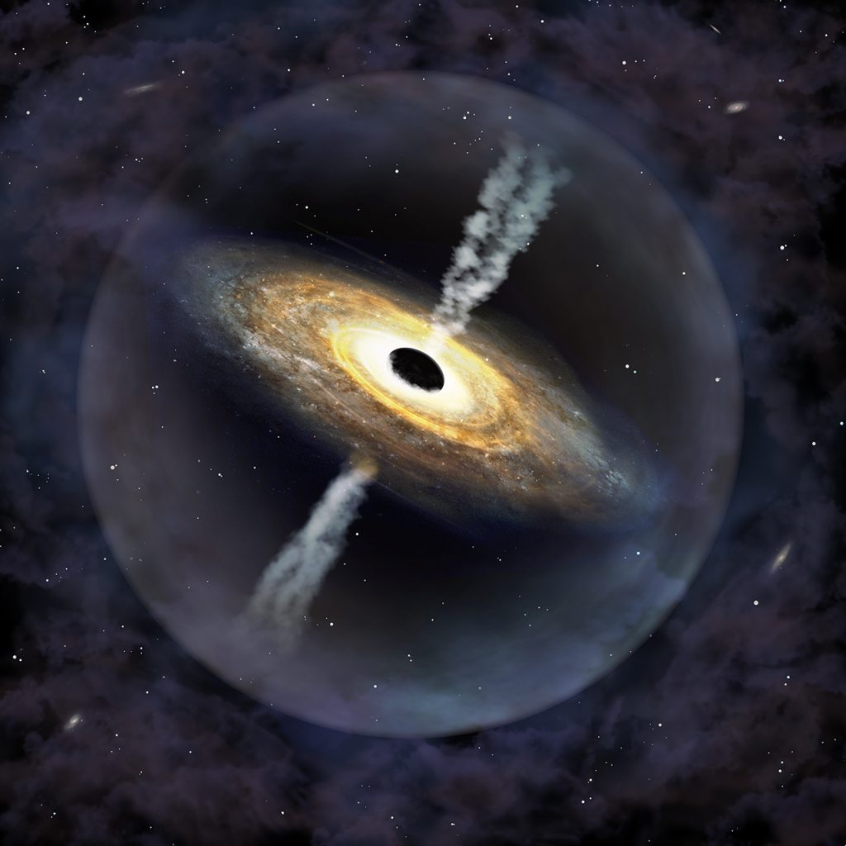
-SUPERMASSIVE BLACK HOLES
Supermassive black holes are the largest and most powerful type of black holes known in the universe. Unlike stellar-mass black holes, which are formed from the death of massive stars, supermassive black holes have masses ranging from millions to billions of times the mass of our Sun. They are found at the centres of most large galaxies, including our own Milky Way. Their origin remains one of the biggest mysteries in astrophysics, but their influence on the structure and evolution of galaxies is undeniable.
Photograph of an stellar mass black hole------
The exact process by which supermassive black holes form is still not fully understood. One theory suggests that they could have started as smaller black holes—perhaps from the collapse of very large gas clouds or from the merging of many stellar-mass black holes over time. These objects may have grown by continuously pulling in matter from their surroundings, including gas, stars, and even other black holes. Over billions of years, through a process called accretion, they gained enormous mass and became the giants we observe today. Another theory proposes that they formed directly from massive clouds of gas in the early universe, bypassing the smaller black hole stage altogether.
Despite their immense size, supermassive black holes are difficult to observe directly because no light can escape from them. However, scientists can detect their presence by observing how they affect nearby stars, gas, and light. When material falls toward a supermassive black hole, it forms a spinning disk called an accretion disk. As this material heats up due to friction and gravity, it emits intense radiation—especially in the X-ray and ultraviolet regions of the spectrum. In some cases, this activity creates a quasar, one of the brightest and most energetic objects in the universe, which can outshine entire galaxies.
The most famous example of a supermassive black hole is Sagittarius A*, located at the centre of the Milky Way galaxy. It has a mass of about 4 million solar masses and was confirmed through observations of stars orbiting rapidly around an invisible centre. In 2019, the Event Horizon Telescope collaboration released the first-ever image of the shadow of a supermassive black hole, located in the centre of the galaxy M87. This historic achievement provided strong evidence supporting Einstein’s theory of general relativity and gave astronomers a new way to study these mysterious objects.
Supermassive black holes also play a crucial role in galaxy evolution. Their gravitational influence can affect the orbits of stars and gas clouds in their host galaxies. In some cases, jets of high-energy particles, powered by the black hole’s magnetic fields, are ejected into space and can influence star formation by heating or dispersing nearby gas. This process, called feedback, can regulate the growth of galaxies and even stop them from forming new stars.
In conclusion, supermassive black holes are essential to our understanding of the universe. They are not only fascinating objects of extreme physics but also powerful engines that shape the formation and development of galaxies. As technology and observational tools continue to improve, scientists hope to uncover how these cosmic giants formed and how they have influenced the universe since its earliest days.
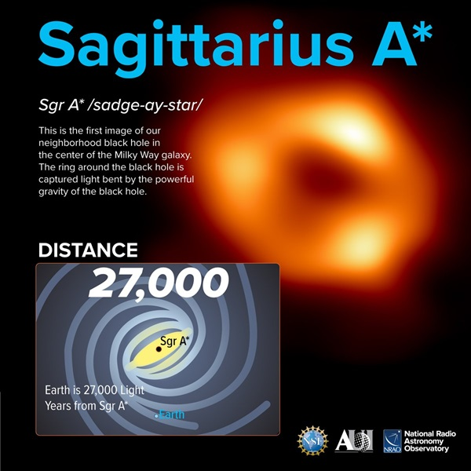
First image of our neighborhood blackhole in center of the milky way galaxy
-INTERMEDIATE MASS BLACK HOLES
Intermediate-mass black holes (IMBHs) are a class of black holes that fall between stellar-mass black holes and supermassive black holes in terms of size and mass. They are believed to have masses ranging from around 100 to 100,000 times the mass of the Sun. While stellar-mass black holes are formed from collapsing stars and supermassive black holes are found in galaxy centres, intermediate-mass black holes are harder to detect and confirm. Because of this, they remain one of the least understood types of black holes in astrophysics.
The formation of intermediate-mass black holes is still under active research, but several theories exist. One idea is that they form through the repeated merging of stellar-mass black holes in dense star clusters. In such environments, multiple collisions over time could build up a larger black hole. Another possibility is that they formed directly from the collapse of massive gas clouds in the early universe, bypassing the stellar stage. A third theory suggests that they may have formed as a stage in the growth of supermassive black holes, acting as the “missing link” between small and large black holes.
Detecting intermediate-mass black holes is very challenging because they are not as active or as massive as supermassive black holes, nor as common as stellar-mass ones. However, scientists have found indirect evidence of their existence. One method involves looking at ultra luminous X-ray sources (ULXs)—objects that emit more X-rays than a typical stellar-mass black hole could account for. If a black hole in such a system is more massive than expected, it could be an IMBH. Other clues come from the motion of stars in globular clusters. If stars are observed orbiting around an invisible, massive object at the cluster's centre, it could suggest the presence of an intermediate-mass black hole.
In recent years, gravitational wave astronomy has also provided potential evidence for intermediate-mass black holes. When two black holes merge, they send ripples through spacetime, known as gravitational waves. In 2020, the LIGO and Virgo observatories detected a merger that produced a black hole with about 142 solar masses, which falls into the intermediate range. This was one of the strongest pieces of evidence yet for the existence of an IMBH.
In summary, intermediate-mass black holes are a crucial piece of the black hole puzzle. They may help explain how supermassive black holes form and how black holes grow over time. Although difficult to observe, new telescopes and gravitational wave detectors are improving our chances of finding and studying them. As more evidence is collected, IMBHs may soon become a well-understood part of cosmic evolution.

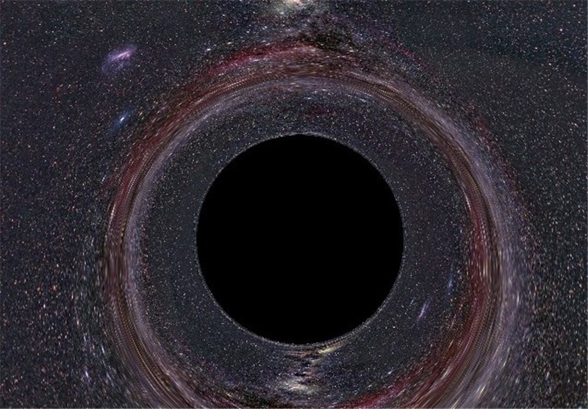
-------------------------------------------------------------------
This Photo by Unknown Author is licensed under CC BY

-PRIMORDIAL BLACK HOLES (HYPOTHETICAL)
Primordial black holes (PBHs) are a fascinating and entirely hypothetical class of black holes that are thought to have formed not from dying stars, but during the earliest moments after the Big Bang. While all known black holes come from the collapse of massive stars or the centres of galaxies, primordial black holes would be much older, possibly dating back to less than a second after the universe began. At that time, the universe was incredibly hot and dense, with small fluctuations in energy and matter spread throughout space. According to some theories, certain regions may have become dense enough to collapse under their own gravity, forming miniature black holes.
What makes PBHs particularly interesting is that they are not limited by the same formation rules as stellar black holes. Their masses could vary from less than a gram (the mass of a mountain) to thousands or even millions of times the mass of the Sun, depending on the conditions of the early universe. Unlike black holes formed from stars, PBHs do not need to reach a certain minimum mass to form. This theoretical flexibility makes them a unique candidate for explaining certain cosmic phenomena. However, because they would not be formed by visible processes like star death or collisions, detecting them is extremely challenging.
One of the main reasons scientists are so interested in primordial black holes is their potential connection to dark matter. Dark matter is a mysterious substance that makes up about 85% of all matter in the universe, yet it cannot be seen directly and does not emit light. If PBHs exist in large numbers and in certain mass ranges, they could account for some or even all of the dark matter. In addition, they could help solve other cosmic puzzles, such as the rapid growth of supermassive black holes in the early universe. Since traditional black hole formation models cannot easily explain how these enormous objects formed so quickly after the Big Bang, PBHs might serve as the early “seeds” that eventually grew into the supermassive black holes we observe today in the centres of galaxies.
Despite decades of speculation, no confirmed evidence of PBHs has yet been found. However, modern astrophysics is making it increasingly possible to look for indirect signs of their existence. Instruments like the LIGO and Virgo gravitational wave detectors can observe black hole mergers, and some of these events suggest the presence of black holes with masses that are difficult to explain by stellar collapse alone. Other studies involve analysing the cosmic microwave background (CMB) for patterns that would have been disturbed by early PBHs or looking for gamma-ray bursts caused by very small PBHs evaporating through a process called Hawking radiation. This process, proposed by physicist Stephen Hawking, predicts that black holes slowly lose mass over time by emitting energy. If true, small PBHs may already have completely evaporated, but larger ones might still exist and be detectable.
In conclusion, primordial black holes remain one of the most intriguing theoretical ideas in cosmology. They offer possible answers to major mysteries like dark matter, early galaxy formation, and the physics of the early universe. Although they have not yet been directly observed, ongoing research, improved detection methods, and advanced space observatories may one day confirm their existence. If proven, PBHs would not only change our understanding of black holes but also shed light on the very beginning of the universe and the forces that shaped everything we see today.
------------------------------------------

4---STRUCTURE & PROPERTIES
-EVENT HORIZON & SINGULARITY
Black holes are fascinating objects predicted by Einstein’s theory of general relativity. They represent regions in space where gravity is so strong that nothing—not even light—can escape once it crosses a certain boundary. Two fundamental components define a black hole's behaviour: the event horizon and the singularity. Understanding their structure and properties offers deep insights into the fabric of spacetime, the limits of physics, and the nature of extreme gravitational fields.

1. Event Horizon
1.1 Definition and Concept
The event horizon is a theoretical boundary surrounding a black hole. It marks the point at which the escape velocity equals the speed of light. Any object, including light itself, that crosses this boundary is inevitably drawn into the black hole’s centre. The event horizon is not a physical surface but a mathematical boundary in spacetime.
In the simplest case of a non-rotating, uncharged black hole (known as a Schwarzschild black hole), the radius of the event horizon is known as the Schwarzschild radius and is given by:
​
$$r_{s}=\frac{2GM}{c^{2}}$$Where:
- G is the gravitational constant,
- M is the mass of the black hole,
- c is the speed of light.
The event horizon forms a sphere around the singularity and grows larger as the black hole gains mass.
1.2 Physical Properties
One-Way Membrane
The event horizon functions as a one-way membrane. While matter and radiation can fall in, nothing can exit. This makes the interior of the black hole causally disconnected from the external universe.
Gravitational Time Dilation
Time behaves very differently near the event horizon. For an outside observer, time appears to slow down for an object approaching the event horizon. The object seems to freeze in place and become increasingly redshifted, never fully appearing to enter the black hole. However, from the infalling object’s own perspective, it crosses the horizon in finite time.
Lack of Local Indicators
Interestingly, an observer falling into a black hole does not notice any special change upon crossing the event horizon. The boundary is not marked by any visible or tangible feature, making it undetectable locally.
1.3 Quantum Effects: Hawking Radiation
Stephen Hawking proposed that black holes are not completely black. Quantum fluctuations near the event horizon lead to the creation of virtual particle pairs, one of which may fall into the black hole while the other escapes. This process results in Hawking radiation, which allows black holes to lose mass over time and possibly evaporate completely, given enough time. This radiation is extremely weak for large black holes, making it nearly impossible to detect with current technology.

2. Singularity
2.1 Definition and Concept
The singularity is the central point of a black hole where all of its mass is thought to be concentrated. It is a point of infinite density and zero volume, where the curvature of spacetime becomes infinite. At this point, the known laws of physics, including general relativity, break down completely.
Unlike the event horizon, the singularity is hidden deep inside the black hole, beyond the reach of any external observation. According to general relativity, once matter crosses the event horizon, it is inevitably crushed into the singularity by the overwhelming gravitational forces.
2.2 Types of Singularities
Point Singularity
In a non-rotating (Schwarzschild) black hole, the singularity is a single point at the centre of the black hole, where all matter is compressed.
Ring Singularity
In a rotating (Kerr) black hole, the singularity takes the shape of a ring. This is due to the black hole’s angular momentum, which causes spacetime to warp in more complex ways. The ring singularity leads to some interesting theoretical possibilities, including the potential for closed time like curves (paths that could allow time travel) and wormholes, though these remain speculative and unstable.
2.3 Physical Properties
Breakdown of Physics
At the singularity, densities and gravitational forces become infinite. General relativity cannot describe what happens here, and quantum effects are expected to dominate. However, since we lack a complete theory of quantum gravity, the true nature of the singularity remains unknown.
Gravitational Collapse
The singularity forms as a result of gravitational collapse. When a massive star exhausts its nuclear fuel, its core collapses under gravity. If the mass is above a certain limit (the Tolman-Oppenheimer-Volkoff limit), no known force can halt the collapse, leading to the formation of a black hole and eventually a singularity.
Hidden from View
Because the singularity lies within the event horizon, it cannot be observed directly. This gives rise to the cosmic censorship conjecture, which suggests that singularities are always hidden inside horizons, preventing “naked singularities” from existing in nature.

3. Relationship Between Event Horizon and Singularity
3.1 Causal Structure
The event horizon acts as a shield that hides the singularity from the outside universe. Nothing that happens within the event horizon can influence events outside it. This creates a causal disconnection, where the singularity can affect its surroundings by pulling in matter, but it cannot be observed or interacted with.
3.2 Formation and Evolution
When a black hole forms from the collapse of a massive star, the event horizon appears first, followed by the creation of a singularity inside it. As the black hole accumulates more mass, the event horizon expands, but the singularity remains a point (or ring) of infinite density at the centre.
3.3 Challenges to Physics
The incompatibility between general relativity (which governs the event horizon’s formation and behaviour) and quantum mechanics (which should explain what happens near or at the singularity) is one of the greatest unsolved problems in physics. Scientists believe that a theory of quantum gravity, such as string theory or loop quantum gravity, may resolve the paradoxes associated with singularities.
The event horizon and singularity are not just features of black holes; they are windows into the fundamental nature of space, time, and gravity. The event horizon defines the boundary of no return, while the singularity marks a breakdown in our current physical theories. Despite being invisible, these entities influence the motion of stars, the dynamics of galaxies, and the structure of the universe itself. Continuing to study them—both theoretically and through observations like the Event Horizon Telescope—may eventually lead us to a deeper understanding of the cosmos and the unification of gravity with quantum mechanics.
------------------------------------------

-SCHWARZSCHILD & KERR BLACK HOLES
Black holes are solutions to Einstein’s field equations that describe regions where gravity is so intense that not even light can escape. The two most common types are the Schwarzschild black hole, which is static and non-rotating, and the Kerr black hole, which includes rotation. These two models form the basis for much of our understanding of black holes in astrophysics.

1. Schwarzschild Black Hole
The Schwarzschild black hole is the simplest type of black hole and was the first exact solution to Einstein’s general relativity equations. It assumes a spherically symmetric mass with no electric charge and no angular momentum.
- It is non-rotating, uncharged, and perfectly spherical.
The only property defining this black hole is its mass. This solution is idealized but useful in many contexts where rotation and charge are negligible.
The structure of a Schwarzschild black hole includes an event horizon and a singularity. The event horizon is a boundary beyond which nothing, not even light, can escape. Its radius is known as the Schwarzschild radius, given by the formula:
$$r_{s}=\frac{2GM}{c^{2}}$$

- The Schwarzschild radius defines the size of the event horizon.
- The singularity is a point of infinite density at the centre of the black hole.
Outside the event horizon, the gravitational field behaves like that of any other spherical mass. But once crossed, all paths lead to the singularity.
- No observer can avoid the singularity after crossing the event horizon.
From a distant observer’s viewpoint, time slows down for an object approaching the event horizon — a phenomenon known as gravitational time dilation. However, the falling object itself experiences no change when crossing the horizon.
- Time appears to stop at the event horizon from a distant observer’s perspective.
The Schwarzschild solution helps describe the gravitational field outside spherical, non-rotating stars and black holes.

2. Kerr Black Hole
The Kerr black hole is a more realistic and complex model, accounting for rotation. It was discovered by Roy Kerr in 1963 and describes a rotating, uncharged black hole. Most real black holes in space are believed to be of this type.
- Kerr black holes have mass and angular momentum (spin).
Unlike the Schwarzschild black hole, the Kerr black hole is not spherically symmetric but axisymmetric, meaning it is symmetric only around its axis of rotation.
- Rotation causes the black hole to flatten at the poles and bulge at the equator.
The Kerr black hole introduces two new features: the ergosphere and the ring singularity. The ergosphere is a region outside the event horizon where space itself is dragged around by the rotating black hole — a phenomenon called frame dragging.
- In the ergosphere, all objects must co-rotate with the black hole.
- The singularity in a Kerr black hole is ring-shaped, not a point.
The presence of angular momentum changes the structure significantly. There are two horizons: the outer event horizon and the inner Cauchy horizon.
- Kerr black holes have two horizons due to rotation.
- They allow for more complex internal structures, possibly even wormholes.
Kerr black holes also support the Penrose process, which theorizes that it is possible to extract energy from a rotating black hole by using the ergosphere.
- Energy can be extracted from a Kerr black hole through the Penrose process.
This makes the Kerr black hole a potential engine for high-energy astrophysical phenomena like quasars and relativistic jets.

3. Key Differences Between Schwarzschild and Kerr Black Holes
While both Schwarzschild and Kerr black holes are solutions to general relativity, they differ in several fundamental ways.
- Schwarzschild black hole has no rotation; Kerr black hole spins.
- Schwarzschild is spherically symmetric; Kerr is axisymmetric.
- Schwarzschild has a point singularity; Kerr has a ring singularity.
- Kerr black holes have two horizons; Schwarzschild has one.
- Frame dragging occurs only in Kerr black holes.
The presence of spin in Kerr black holes creates a richer, more dynamic environment and makes them more relevant for real-world astrophysical models.
3. Key Differences Between Schwarzschild and Kerr Black Holes
While both Schwarzschild and Kerr black holes are solutions to general relativity, they differ in several fundamental ways.
- Schwarzschild black hole has no rotation; Kerr black hole spins.
- Schwarzschild is spherically symmetric; Kerr is axisymmetric.
- Schwarzschild has a point singularity; Kerr has a ring singularity.
- Kerr black holes have two horizons; Schwarzschild has one.
- Frame dragging occurs only in Kerr black holes.
The presence of spin in Kerr black holes creates a richer, more dynamic environment and makes them more relevant for real-world astrophysical models.
Schwarzschild and Kerr black holes are foundational models in black hole physics. The Schwarzschild black hole represents an idealized, non-rotating case, useful for basic theory and approximation. The Kerr black hole, on the other hand, offers a more accurate description of real astrophysical black holes due to its incorporation of rotation.
- Most black holes observed in the universe are believed to be Kerr black holes.
Together, these models help us understand the gravitational behaviour of compact objects, test the limits of general relativity, and explore the frontier of theoretical physics, including the possibility of wormholes, time loops, and quantum gravity.
------------------------------------------

-HAWKING RADIATION & EVAPORATION
Black holes were once believed to be completely black, absorbing everything that crossed their event horizons. However, in 1974, Stephen Hawking introduced a revolutionary idea: black holes can emit radiation. This discovery emerged from combining principles of quantum mechanics with general relativity. Known as Hawking radiation, this phenomenon implies that black holes are not entirely cut off from the universe but can slowly lose energy and mass.
- Hawking radiation was proposed by Stephen Hawking in 1974.
- It shows that black holes can emit radiation and lose mass.
- This process happens near the event horizon due to quantum effects.
The origin of Hawking radiation lies in quantum fluctuations. In the vacuum of space, particle-antiparticle pairs continuously form and annihilate. Near the event horizon, one particle may fall into the black hole while the other escapes into space. When this happens, energy appears to be radiated away from the black hole. According to Einstein’s equation $E=mc^{2}$, this loss of energy corresponds to a loss of mass for the black hole. The radiation observed from this process is what we call Hawking radiation.
- Particle-antiparticle pairs constantly form in empty space due to quantum mechanics.
- Near a black hole, one particle can escape while the other is trapped.
- The escaping particle carries energy away, reducing the black hole’s mass.
As Hawking radiation continues over time, the black hole gradually loses mass, leading to a process called black hole evaporation. The rate of radiation is inversely proportional to the black hole’s mass: the smaller the black hole, the more intense the radiation. As a result, small black holes radiate faster and shrink more quickly. In the final stages of evaporation, it is theorized that the black hole could emit a burst of high-energy particles, although this has not yet been observed.
- Hawking radiation causes black holes to slowly evaporate.
- Smaller black holes emit more radiation and evaporate faster.
- The final stage might involve a high-energy explosion (still theoretical).
This phenomenon has deep implications for physics. It suggests that black holes behave like thermodynamic systems, possessing temperature and entropy. This challenges earlier beliefs that black holes could only grow or remain static. The idea of black hole evaporation also leads to the information paradox—a major question in theoretical physics about whether information that falls into a black hole is lost forever or preserved somehow through radiation.
- Black holes have properties like temperature and entropy.
- Hawking radiation links quantum mechanics, thermodynamics, and relativity.
- It raises the "information paradox": is information truly lost in black holes?
Although Hawking radiation has not yet been directly detected due to its extremely weak nature (especially for large black holes), it remains one of the most influential ideas in modern physics. It reshaped our understanding of black holes, turning them from eternal absorbers into dynamic, evolving objects that can eventually vanish. Ongoing research continues to explore its implications for quantum gravity, black hole thermodynamics, and the structure of the universe itself.
- Hawking radiation is still a theoretical prediction, not directly observed.
- It redefined black holes as objects that can change, shrink, and vanish.
- It is central to modern research in black hole physics and cosmology.
------------------------------------------

-ACCRETION DISKS & RELATIVISTIC JETS
Accretion disks and relativistic jets are two of the most powerful and energetic structures found in the universe. They are often associated with extremely dense and compact objects such as black holes, neutron stars, and white dwarfs. These structures not only provide visual evidence of matter interacting with extreme gravitational fields but also play a major role in the evolution of galaxies and the distribution of energy in space.
An accretion disk is a rotating disk of gas, dust, plasma, and other forms of matter that orbit a central body. The material in the disk slowly spirals inward due to gravitational attraction and internal friction. As the material moves inward, it heats up significantly because of viscous forces and the release of gravitational potential energy. This process causes the accretion disk to radiate energy, often becoming one of the brightest sources of radiation in the universe.
- Accretion disks form when matter orbits and falls into compact objects.
- Friction and gravitational forces convert potential energy into heat and radiation.
- The inner regions of the disk can reach temperatures of millions of degrees.
The structure and behaviour of the disk are governed by physical processes such as angular momentum transfer, magnetohydrodynamics, and relativistic effects near massive objects. Angular momentum must be transferred outward for matter to spiral inward. This transfer is enabled by viscosity and turbulence within the disk. In some models, magnetic fields contribute significantly to these processes, especially in what is known as the magnetorotational instability (MRI), which helps drive turbulence and energy transport.
- Angular momentum must be lost for matter to spiral inward.
- Magnetic fields play a major role in transporting energy and momentum.
- The magnetorotational instability is key to sustaining turbulence in the disk.
Accretion disks are not exclusive to black holes. They can form around many astronomical bodies, including young protostars, white dwarfs in binary systems, and neutron stars. However, disks around black holes—especially supermassive black holes—are the most extreme. As matter approaches the event horizon of a black hole, the relativistic speeds and gravitational time dilation create a glowing, high-energy disk observable in X-rays, ultraviolet, and sometimes visible light.
- Accretion disks occur in many astrophysical systems, not just black holes.
- Supermassive black holes have the largest and most energetic accretion disks.
- Observations of disks offer indirect evidence of black holes.
In many active systems, accretion disks do more than just feed matter into black holes—they also produce relativistic jets. These are narrow beams of ionized particles that are ejected from the poles of the accreting object at nearly the speed of light. Though the exact mechanisms remain under study, the leading explanation involves twisted magnetic field lines anchored in the disk and the spinning black hole. These fields can channel some of the disk’s energy outward along the rotation axis, launching plasma jets far into interstellar or even intergalactic space.
- Relativistic jets are launched from the poles of spinning accretion disks.
- Magnetic fields help funnel matter away at relativistic speeds.
- These jets are often symmetric, extending in opposite directions.
The power of these jets is immense. In systems such as quasars and active galactic nuclei (AGN), jets can travel millions of light-years, transporting energy far from the central black hole. They emit radiation across the electromagnetic spectrum—from radio waves to gamma rays—and can be detected with radio telescopes, X-ray observatories, and even optical telescopes. The shape and brightness of jets vary depending on orientation, distance, and the nature of the surrounding environment.
- Jets can span from thousands to millions of light-years in length.
- Their emissions cover the entire electromagnetic spectrum.
- The orientation of the jet affects how we observe it (e.g., blazars).
Relativistic jets also influence the galactic environment. As they interact with interstellar or intergalactic gas, they create shock waves, heat surrounding matter, and can even suppress or stimulate star formation. In this way, the activity of a central black hole or compact object can have large-scale effects on its host galaxy, a phenomenon known as feedback.
- Jets affect surrounding gas and star formation within galaxies.
- Black hole activity helps regulate galaxy growth and structure.
- This feedback loop is important in galaxy evolution models.
In the case of stellar-mass black holes and neutron stars in binary systems, accretion and jet processes are observed on much shorter timescales. These are often seen as X-ray binaries, where a normal star donates matter to a companion black hole or neutron star. Periodic changes in brightness or emission provide clues about disk dynamics and jet activity.
- Accreting black holes in binary systems are observable in X-rays.
- These systems evolve rapidly and show dynamic changes in emission.
- Jets can be observed even from stellar-mass black holes.
Accretion disks and relativistic jets remain among the most studied and mysterious structures in astrophysics. They provide a natural laboratory for understanding extreme conditions, including strong gravity, high-energy particle acceleration, and relativistic motion. The study of these features continues to inform our understanding of both small-scale astrophysical processes and large-scale cosmic evolution.
- Disks and jets probe physics under extreme gravity and high energies.
- They are key to understanding black holes, galaxy formation, and cosmic feedback.
- Continued observations and simulations aim to unlock the details of their mechanisms.

5---EFFECTS ON SURROUNDING SPACE
- GRAVITATIONAL LENSING
Gravitational lensing is a powerful phenomenon predicted by Einstein’s general theory of relativity, where the gravity of a massive object bends the path of light traveling near it. Unlike traditional lenses made of glass, gravitational lenses are formed by the curvature of spacetime itself. When light from a distant source, such as a galaxy or quasar, passes near a massive foreground object like another galaxy or a cluster of galaxies, its path is bent, magnified, and sometimes distorted. This bending causes the light to follow curved paths, and as a result, observers may see multiple images of the same object, arcs, or rings, depending on the alignment.
- Gravitational lensing is caused by massive objects bending the path of light.
- It is predicted by Einstein’s general relativity and proven by observation.
- Light can be distorted, magnified, or duplicated depending on alignment.
There are three main types of gravitational lensing: strong lensing, weak lensing, and microlensing. In strong lensing, the alignment between the background source and the foreground mass is very close. This results in noticeable distortions such as Einstein rings, giant arcs, and multiple visible images. Strong lensing is often observed in galaxy clusters, where the combined mass of dark matter and visible matter creates significant warping of light paths.
- Strong lensing occurs when the source, lens, and observer are well-aligned.
- It can create visible effects like multiple images, arcs, and Einstein rings.
- Galaxy clusters are common strong lenses due to their large masses.
Weak lensing is subtler and harder to detect. Instead of producing clear multiple images, it slightly distorts the shapes of background galaxies. By studying the average alignment of many such galaxies over a large area of the sky, astronomers can map the distribution of dark matter, which does not emit light but contributes gravitationally. Weak lensing is crucial for cosmology because it allows scientists to study the large-scale structure of the universe and how matter is distributed within it.
- Weak lensing causes small distortions in background galaxy shapes.
- It is used to map dark matter and understand cosmic structure.
- It requires statistical analysis over many galaxies.
Microlensing happens when a relatively small object, such as a star or planet, passes in front of a background source. Although the object is too small to produce multiple images, it can still cause a temporary increase in the brightness of the background star. This brightening occurs because the gravity of the foreground object focuses more light toward Earth. Microlensing is often used to detect exoplanets, black holes, or compact dark matter objects, especially in our own galaxy.
- Microlensing causes a temporary brightening of distant stars.
- It can detect planets and dark objects that are otherwise invisible.
- Unlike strong lensing, microlensing doesn’t resolve multiple images.
The most dramatic example of gravitational lensing is the Einstein ring, named after Albert Einstein. When the background source, lensing object, and observer are perfectly aligned, the light is bent into a complete ring. Although perfect rings are rare, partial rings and arcs are more commonly observed and still provide valuable information about the masses of the lensing objects and the distance to background sources.
- Einstein rings occur under perfect alignment conditions.
- They are rare but provide direct measurements of mass and distance.
- Partial arcs and rings are more commonly seen.
Gravitational lensing is not just a visual curiosity—it is a critical tool for astrophysics and cosmology. It allows astronomers to weigh massive objects that are otherwise invisible, such as dark matter halos around galaxies and clusters. Since gravitational lensing depends only on mass and not on whether that mass emits light, it serves as a direct probe of total matter, both visible and invisible. This makes it especially valuable for studying dark energy, galaxy evolution, and the expansion of the universe.
- Lensing measures total mass regardless of visibility.
- It helps study dark matter, dark energy, and galaxy formation.
- It contributes to our understanding of the universe’s expansion.
One of the earliest confirmations of gravitational lensing came during a solar eclipse in 1919, when Arthur Eddington measured the position of stars near the Sun and found them slightly shifted due to the Sun’s gravitational field. This provided the first experimental evidence supporting Einstein’s theory. Since then, telescopes like the Hubble Space Telescope and observatories like LSST and Euclid have refined our ability to observe and analyse lensing events.
- The 1919 eclipse confirmed Einstein’s prediction using the Sun’s gravity.
- Modern telescopes have observed thousands of lensing events.
- Space missions are designed to map lensing for cosmological studies.
Another remarkable application of gravitational lensing is time delay cosmography. When light from a quasar travels around a lensing galaxy in multiple paths, the light takes different amounts of time to arrive at Earth. Measuring this time delay allows astronomers to calculate the Hubble constant, which describes the expansion rate of the universe. This provides an independent check on other methods and helps resolve discrepancies between different measurements.
- Time delays between lensed images help measure the Hubble constant.
- This method offers an independent way to study cosmic expansion.
- It can help resolve tension in current cosmological measurements.
Gravitational lensing can also act as a natural telescope, magnifying faint background galaxies that would otherwise be too distant or too dim to observe. This effect is often used in the study of the early universe, allowing scientists to see galaxies as they were billions of years ago. Lensing helps reveal the structure and formation of the first galaxies and gives insights into the early stages of cosmic history.
- Lensing magnifies distant galaxies, acting like a cosmic telescope.
- It allows observation of early-universe objects otherwise beyond reach.
- It enhances our understanding of the first stars and galaxies.
-------------------------------

-IMPACT ON STARS, PLANETS & GALAXIES
Gravitational lensing primarily affects light, not the physical structure of stars, planets, or galaxies. However, it has a profound impact on how we observe and understand these objects. By bending the path of light from distant stars and galaxies, lensing allows astronomers to study objects that are otherwise too far, too faint, or obscured by other matter. In this way, gravitational lensing does not physically alter stars or galaxies but significantly changes our ability to detect and analyse them.
- Gravitational lensing affects how we observe, not the physical form of stars or planets.
- It bends and magnifies light, making distant objects more visible.
- Lensing enhances astronomical observations across large cosmic distances.
In the case of stars, gravitational microlensing is one of the few methods available to detect dark and invisible objects such as black holes, neutron stars, or rogue planets that pass in front of them. When a compact object crosses the line of sight to a distant star, its gravity bends the starlight and temporarily makes the star appear brighter. This phenomenon allows astronomers to detect objects without light—even isolated ones drifting through space.
- Microlensing causes temporary brightening of background stars.
- It allows detection of compact, non-luminous objects like rogue planets and black holes.
- It offers one of the best methods for studying unseen stellar-mass objects.
Gravitational lensing has also proven essential in exoplanet discovery. When a star acts as a lens and briefly magnifies a background star, the presence of a planet around the lensing star can create a secondary spike in brightness. This variation provides indirect but strong evidence of a planet's existence and characteristics. Microlensing events like these are often short-lived and require continuous sky surveys to detect, but they reveal planetary systems that cannot be studied by other methods.
- Lensing helps discover exoplanets by detecting planetary signatures during stellar lensing events.
- It is useful for finding planets in systems too distant for other detection techniques.
- These discoveries contribute to our understanding of planetary populations in the galaxy.
For galaxies, gravitational lensing allows astronomers to study their structure, composition, and distribution—particularly those too distant or faint to see directly. When a massive galaxy or galaxy cluster acts as a lens, it can magnify and distort the light from more distant background galaxies. This process often results in elongated arcs, duplicate images, or even Einstein rings. These distorted shapes provide astronomers with data about both the lensing mass and the background object.
- Lensing magnifies and distorts background galaxies, allowing study of distant galaxies.
- The distorted light helps determine the mass distribution of lensing galaxies.
- It also reveals galaxies from the early universe that would otherwise be unobservable.
Gravitational lensing also plays a critical role in mapping dark matter. Galaxies and galaxy clusters that act as lenses often have much more gravitational influence than can be explained by visible matter alone. The degree of lensing reveals the presence of dark matter—the unseen substance that makes up most of the universe’s mass. Through weak lensing, astronomers can measure slight distortions in the shapes of thousands of background galaxies to infer the structure and density of dark matter halos.
- Lensing shows that visible matter is only part of a galaxy’s mass.
- Weak lensing is a key method for mapping dark matter on cosmic scales.
- The results confirm that galaxies are embedded in large dark matter halos.
In terms of galaxy evolution, gravitational lensing helps astronomers understand how galaxies form and change over time. By magnifying distant galaxies from the early universe, lensing enables the study of young galaxies during their formative stages. These observations shed light on how star formation, galactic mergers, and supermassive black holes influenced the development of galaxies we see today. Without gravitational lensing, such faint and faraway galaxies would remain hidden from even the most powerful telescopes.
- Lensing enables observation of early galaxies, helping track their growth and behaviour.
- It offers insight into star formation and black hole activity in young galaxies.
- It helps reconstruct the timeline of galactic evolution from the early universe.
In some cases, gravitational lensing can even help detect transient events, such as supernovae or gamma-ray bursts, that occur in distant galaxies. When the light from such an event is lensed by a galaxy or cluster, multiple images of the explosion may be seen at different times. These time-delayed views allow scientists to study the event repeatedly and gain information about the expansion rate of the universe through techniques like time-delay cosmography.
- Lensing can duplicate light from supernovae or gamma-ray bursts across time.
- Time delays provide insights into cosmic distances and the Hubble constant.
- It allows multiple views of the same event, improving data accuracy.
Even though planets and stars are not directly affected in their structure by gravitational lensing, the indirect consequences of lensing are tremendous. It expands the boundary of what can be studied, enabling discoveries that otherwise would be impossible due to distance or faintness. From detecting exoplanets and rogue black holes to revealing the first galaxies and mapping dark matter, gravitational lensing has revolutionized our understanding of the universe.
- Lensing doesn’t physically impact stars or planets, but enhances their detectability.
- It allows for the discovery of invisible or hidden celestial objects.
- It plays a central role in modern cosmology and astrophysics.
--------------------------------
-TIME DILATION NEAR BLACK HOLES
Time dilation is a fundamental prediction of Einstein’s general theory of relativity, and it becomes particularly extreme in the environment near a black hole. According to relativity, the presence of a massive object warps spacetime, causing time to pass more slowly for an observer close to the mass compared to one farther away. Black holes, being the densest and most compact objects in the universe, produce the most intense gravitational fields, and therefore the most extreme time dilation effects known in nature.
- Time dilation is the slowing of time in a strong gravitational field.
- It is most noticeable near massive bodies, especially black holes.
- Einstein’s general relativity explains time as part of the warped fabric of spacetime.
For a stationary observer far from the black hole, time flows normally. But as another observer moves closer to the black hole, particularly near the event horizon—the boundary beyond which nothing can escape—their time appears to slow down relative to the distant observer. From the perspective of someone watching from afar, the person nearing the event horizon seems to slow to a stop, never quite crossing it. This apparent “freezing” in time is not experienced by the person falling in, but it is a real relativistic effect when comparing frames of reference.
- Time passes more slowly near a black hole compared to far away.
- To an external observer, infalling objects appear to slow as they approach the event horizon.
- This effect is due to gravitational time dilation, not an illusion.
The mathematical description of this phenomenon comes from the Schwarzschild metric, a solution to Einstein’s equations that describes the spacetime around a non-rotating, uncharged black hole. In the Schwarzschild geometry, time dilation becomes infinitely large as an object approaches the event horizon. The formula includes a term that shows time stretches out, and this stretching increases dramatically the closer one gets to the Schwarzschild radius.
- Schwarzschild geometry describes non-rotating black holes.
- Time dilation becomes infinite at the event horizon in this model.
- This mathematical treatment explains how time "stretches" near a black hole.
If a person could safely hover just outside the event horizon (which is technically impossible without infinite energy), they would experience only a few seconds while millions or even billions of years could pass for someone observing from Earth. This massive difference in experienced time makes black holes a common feature in science fiction. The concept was popularized in movies like Interstellar, where astronauts experienced only hours near a massive black hole, while years passed for those left behind.
- Close to the event horizon, time almost stops compared to faraway observers.
- Time dilation allows for the possibility of "future travel" in a one-way sense.
- Realistic depictions (e.g., Interstellar) are based on actual physics.
In a rotating black hole, described by the Kerr metric, the effects become more complex. Not only does time slow down, but space itself is dragged along by the black hole's spin—a phenomenon called frame dragging. This means the closer an object gets to the black hole, especially near the ergosphere (a region outside the event horizon), time and space behave in even more distorted ways. Though time still dilates in a similar way, the rotation adds additional curvature and effects on clocks and motion.
- Kerr black holes spin and cause frame dragging of spacetime.
- Time dilation is still present but complicated by rotational effects.
- The ergosphere adds another layer of distortion outside the event horizon.
One way to understand gravitational time dilation is through the concept of gravitational potential. In regions of lower potential (closer to the black hole), clocks tick more slowly. This has been confirmed through experiments even on Earth, such as placing atomic clocks on airplanes or mountains. Although the effect is tiny on Earth, it demonstrates the same principle: clocks in stronger gravity tick slower than those in weaker gravity.
- Gravitational time dilation occurs due to differences in gravitational potential.
- It has been measured on Earth using sensitive atomic clocks.
- The principle scales up dramatically near black holes.
The extreme time dilation near black holes also affects how we observe light and information. Light emitted from near the event horizon is gravitationally redshifted—its wavelength is stretched, and its frequency decreases. As a result, signals or images from near the event horizon appear weaker and slower when received by a distant observer. This redshift is another consequence of time dilation and helps explain why black holes appear "dark."
- Light from near the event horizon is redshifted due to time dilation.
- Gravitational redshift is a direct result of slowed time in deep gravity wells.
- This effect contributes to black holes being nearly invisible.
Time dilation near black holes is not merely a theoretical idea. It has practical implications for our understanding of black hole thermodynamics, information paradoxes, and event horizons. For instance, the Hawking radiation process—where black holes slowly evaporate over immense timescales—is perceived differently depending on one’s position. For an external observer, the black hole evaporates extremely slowly, but near the event horizon, the process could appear very different due to local time rates.
- Time dilation affects the perceived rate of black hole evaporation.
- Hawking radiation is viewed over vastly different time spans depending on the observer.
- This raises deeper questions in physics about information and causality.
From a scientific standpoint, understanding time dilation near black holes helps physicists test general relativity under the most extreme conditions. Observations of matter falling into black holes, and the way it behaves over time, provide indirect evidence of these relativistic effects. Experiments such as those with the Event Horizon Telescope or gravitational wave detectors allow for precise studies of regions close to black hole event horizons, where time dilation is most extreme.
- Studying black holes tests relativity in high-gravity environments.
- Observations support theoretical predictions about time dilation.
- Telescopes and wave detectors confirm effects near event horizons.
In summary, time dilation near black holes is one of the most fascinating consequences of general relativity. It illustrates how time is not absolute, but relative to one’s gravitational environment. While the experience of time for someone falling into a black hole remains smooth and unchanged locally, the view from the outside tells a dramatically different story. This dual perspective reflects the beauty and complexity of the universe as described by Einstein’s theories.
- Time is relative, not fixed—it changes depending on gravity.
- Black holes offer extreme examples of this relativistic nature of time.
- The study of time dilation bridges fundamental physics with cosmic observation.
---------------------------------

6---OBSERVATIONAL EVIDENCE
-METHODS USED TO DETECT BLACK HOLES
Black holes, by their nature, do not emit light, making them impossible to observe directly with traditional optical telescopes. However, their gravitational influence on nearby matter and light provides several indirect methods for detecting their presence. Scientists use a combination of techniques involving X-rays, radio waves, gravitational waves, and stellar motion analysis to find and study black holes. These methods allow astronomers to determine not only the location of black holes but also their mass, spin, and interactions with surrounding objects.
- Black holes are invisible directly; detection is indirect.
- Their presence is inferred by their effect on nearby matter and energy.
- Observations use multiple wavelengths and methods.
One of the earliest and most successful techniques for detecting black holes is by observing X-ray emissions from accretion disks. When a black hole pulls in gas and dust from a nearby star or surrounding material, it forms a hot, rotating disk known as an accretion disk. The matter in this disk is heated to millions of degrees as it spirals inward, emitting intense X-rays. Instruments such as the Chandra X-ray Observatory and XMM-Newton detect these high-energy signals, which often point to the presence of a stellar-mass or supermassive black hole.
- Accretion disks around black holes emit strong X-rays.
- X-ray telescopes detect these emissions to locate black holes.
- This is common in binary star systems and galactic centres.
Another method involves analysing the motion of stars or gas clouds orbiting an unseen object. If the orbiting material moves in ways that suggest the presence of a massive, compact object that emits no visible light, astronomers suspect a black hole. This approach was used to confirm the supermassive black hole at the centre of the Milky Way, known as Sagittarius A*, by tracking the 16-year orbit of a star called S2. The star’s high velocity and tight orbit revealed an object with over 4 million times the mass of the Sun in a very small region.
- Stellar motion reveals hidden massive objects.
- Unseen gravitational sources suggest black holes.
- S2’s orbit around Sagittarius A* confirmed a central supermassive black hole.
In addition, black holes can be detected through their gravitational lensing effect. When a black hole passes in front of a distant star, its gravity bends the star’s light, temporarily magnifying and distorting it. This effect is known as gravitational microlensing, and it can be used to detect isolated or “rogue” black holes that do not interact with other matter or have an accretion disk. Projects like OGLE (Optical Gravitational Lensing Experiment) and MOA (Microlensing Observations in Astrophysics) have discovered candidate black holes this way.
- Gravitational microlensing reveals black holes via light bending.
- Useful for detecting non-interacting, isolated black holes.
- Light curves from background stars indicate a lensing mass.
In recent years, one of the most revolutionary methods has been the detection of gravitational waves—ripples in spacetime caused by violent cosmic events such as the merger of two black holes. In 2015, the LIGO (Laser Interferometer Gravitational-Wave Observatory) and later Virgo detected such waves for the first time, confirming the existence of black hole binaries and their collisions. These signals provide direct information about the mass and spin of the merging black holes, and they represent a major advancement in astrophysics.
- Gravitational waves are emitted by merging black holes.
- LIGO and Virgo detect these waves with high precision.
- They provide direct proof of black hole existence and properties.
Another method is the observation of radio emissions from relativistic jets, which are narrow beams of particles ejected from the regions near a black hole at nearly the speed of light. These jets, often emitted from the poles of accreting supermassive black holes, can extend for thousands of light-years and emit strong radio signals. Radio telescopes such as the Very Large Array (VLA) and ALMA (Atacama Large Milli meter / sub milli meter Array) help map these structures, indicating the presence of active galactic nuclei powered by black holes.
- Relativistic jets point to active black hole cores in galaxies.
- Jets are observable in radio, infrared, and sometimes visible wavelengths.
- They indicate accretion and magnetic activity near black holes.
Perhaps the most visually dramatic evidence came from the Event Horizon Telescope (EHT), a global network of radio telescopes that captured the first image of a black hole’s shadow in 2019. Located in the galaxy M87, this supermassive black hole was imaged by detecting the silhouette created by the event horizon against the surrounding glowing gas. This achievement confirmed predictions from general relativity and showed the black hole’s size and shape with unprecedented clarity.
- The Event Horizon Telescope imaged a black hole for the first time.
- The image showed a bright ring and a dark shadow: the event horizon.
- It confirmed theoretical models and opened new observational paths.
In summary, although black holes cannot be seen directly, they reveal themselves through their gravitational effects, energetic emissions, and disturbances in spacetime. Each detection method offers different types of information, and often, multiple methods are combined to confirm the presence of a black hole. These observations have transformed black holes from theoretical constructs into well-studied astronomical objects, central to our understanding of galaxy formation, cosmic evolution, and fundamental physics.
- Detection relies on indirect evidence: motion, light, radiation, and spacetime ripples.
- Multiple tools—X-ray, radio, gravitational wave—are used to study black holes.
- These methods have confirmed black holes as real, powerful cosmic phenomena.
------------------------------------------

-FAMOUS BLACKHOLES
Black holes exist in many forms and sizes across the universe, but a few have become well-known due to their scientific importance, unusual characteristics, or striking observational evidence. These famous black holes have helped scientists confirm the predictions of general relativity, study the behaviour of matter in extreme environments, and understand the evolution of galaxies. Below are some of the most notable black holes studied in modern astrophysics.

Sagittarius A*
At the centre of the Milky Way galaxy lies Sagittarius A*, a supermassive black hole with a mass of approximately 4.3 million times that of the Sun. Although it cannot be seen directly, its presence has been inferred by tracking the orbits of nearby stars, especially a star named S2, which orbits extremely close and completes a full orbit in just 16 years. Observations from the Keck Observatory and Very Large Telescope (VLT) provided solid evidence of this central black hole.
- Located at the centre of the Milky Way.
- Mass is over 4 million times that of the Sun.
- Confirmed by tracking stellar orbits like S2.
In 2022, the Event Horizon Telescope (EHT) released the first image of Sagittarius A*, showing a glowing ring of hot gas around a dark central shadow—the black hole’s event horizon. This image matched the theoretical expectations of general relativity and confirmed the existence of the Milky Way’s central black hole visually for the first time.

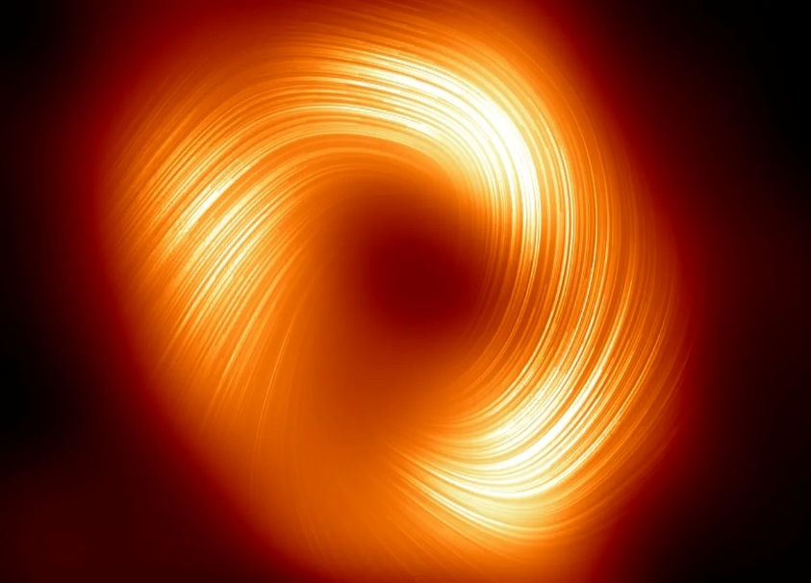
An image of SAGITTAURUS A*------------------------------------------------------------------------------------------------------------------------------
M87*
One of the most iconic black holes in science is the one at the centre of Messier 87 (M87), a massive elliptical galaxy located about 55 million light-years from Earth. In 2019, the first direct image of a black hole was released by the EHT collaboration. The image showed a bright ring of light surrounding a dark central region—the black hole’s shadow. This marked a major scientific milestone and provided visual confirmation of the event horizon’s shape predicted by Einstein’s equations.
- Located in galaxy M87, 55 million light-years away.
- First black hole to be imaged directly.
- Mass is around 6.5 billion times the Sun’s.
This black hole is notable not only for its immense size but also for the relativistic jet it produces—an enormous, high-speed stream of charged particles extending thousands of light-years into space. These jets are powered by the black hole’s magnetic fields and rotation, and they provide crucial insight into how black holes interact with their host galaxies.
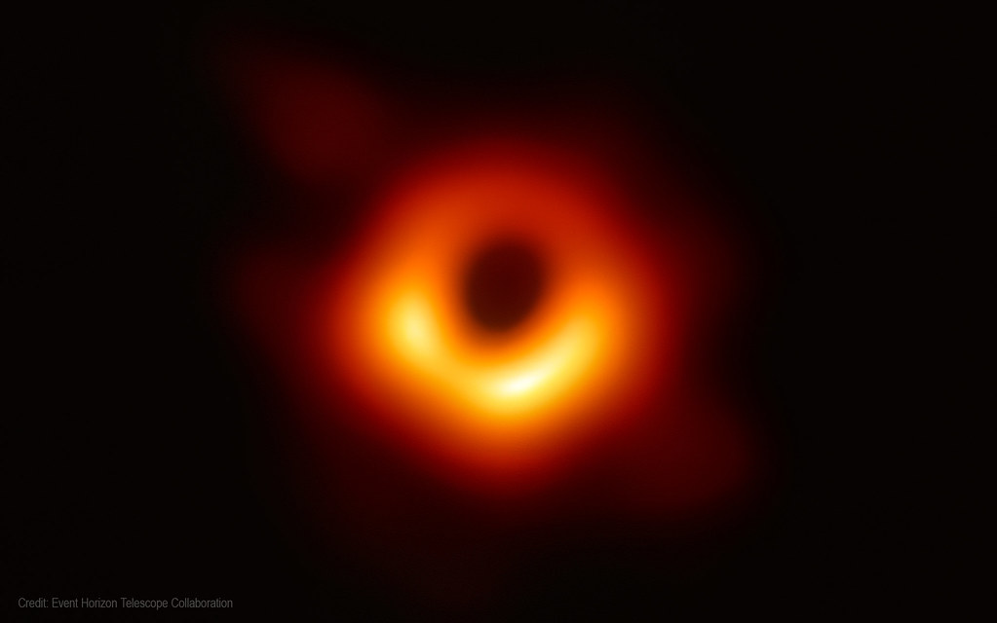
An image of M87*--------------------------------------------------------------------------------------------------------------------------------------

Cygnus X-1
Cygnus X-1 is one of the first stellar-mass black holes ever discovered and remains one of the most studied. Located about 6,000 light-years away in the constellation Cygnus, it was first detected in the 1960s via X-ray emissions. It is part of a binary system, meaning it orbits a massive blue supergiant star, and it pulls material from the star into an accretion disk, which emits intense X-rays.
- First strong black hole candidate discovered.
- Part of a binary system emitting strong X-rays.
- Has about 21 solar masses.
Stephen Hawking famously made a scientific bet against its being a black hole—but later conceded as evidence mounted. Its study helped establish the credibility of black holes as real astrophysical objects, not just mathematical curiosities.
image of it in the next page………..
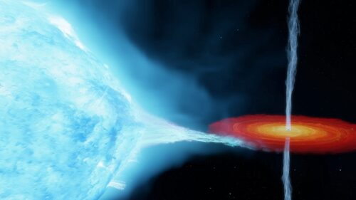
An image of cygnus X-1*---------------------------------------------------------------------------------------------

V404 Cygni
V404 Cygni is another stellar-mass black hole located in a binary system. It lies about 7,800 light-years away and became famous after a massive outburst in 2015, where it emitted flashes of light, radio waves, and X-rays. This activity allowed scientists to study how black holes feed on matter, eject energy, and vary rapidly in brightness.
- Known for its dramatic 2015 outburst.
- Emitted powerful jets and flares during the event.
- Offers insights into black hole feeding behaviour.
This black hole is relatively small—about 9 times the Sun’s mass—but its violent activity showed that even stellar black holes can have major impacts on their surroundings.
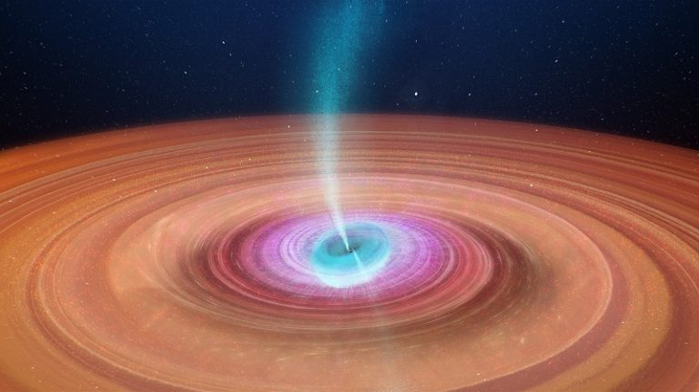
An image of V404 CYGNI*---------------------------------------------------------------------------------------------------------------------------
TON 618
TON 618 is an extremely distant and massive quasar, powered by a hyper-massive black hole. With an estimated mass of more than 66 billion solar masses, it is among the largest black holes ever found. Quasars are highly luminous and active galactic nuclei, with black holes feeding at their centre.
- Estimated to be 66 billion times the Sun’s mass.
- One of the most massive black holes known.
- Located in a distant quasar, over 10 billion light-years away.
Though it lies far beyond our local group of galaxies, its brightness and mass make it one of the most powerful examples of black hole growth and energy output in the universe.
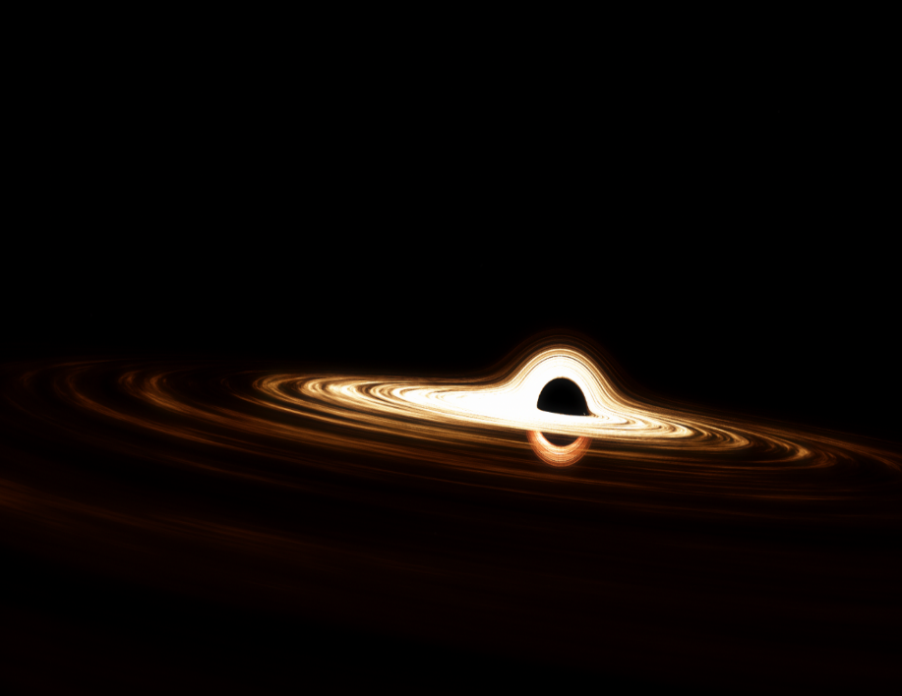
THESE ARE SOME OF THE FAMOUS BLACKHOLES……………………………………………
------------------------------------------
-FIRST EVER BLACK HOLE IMAGE
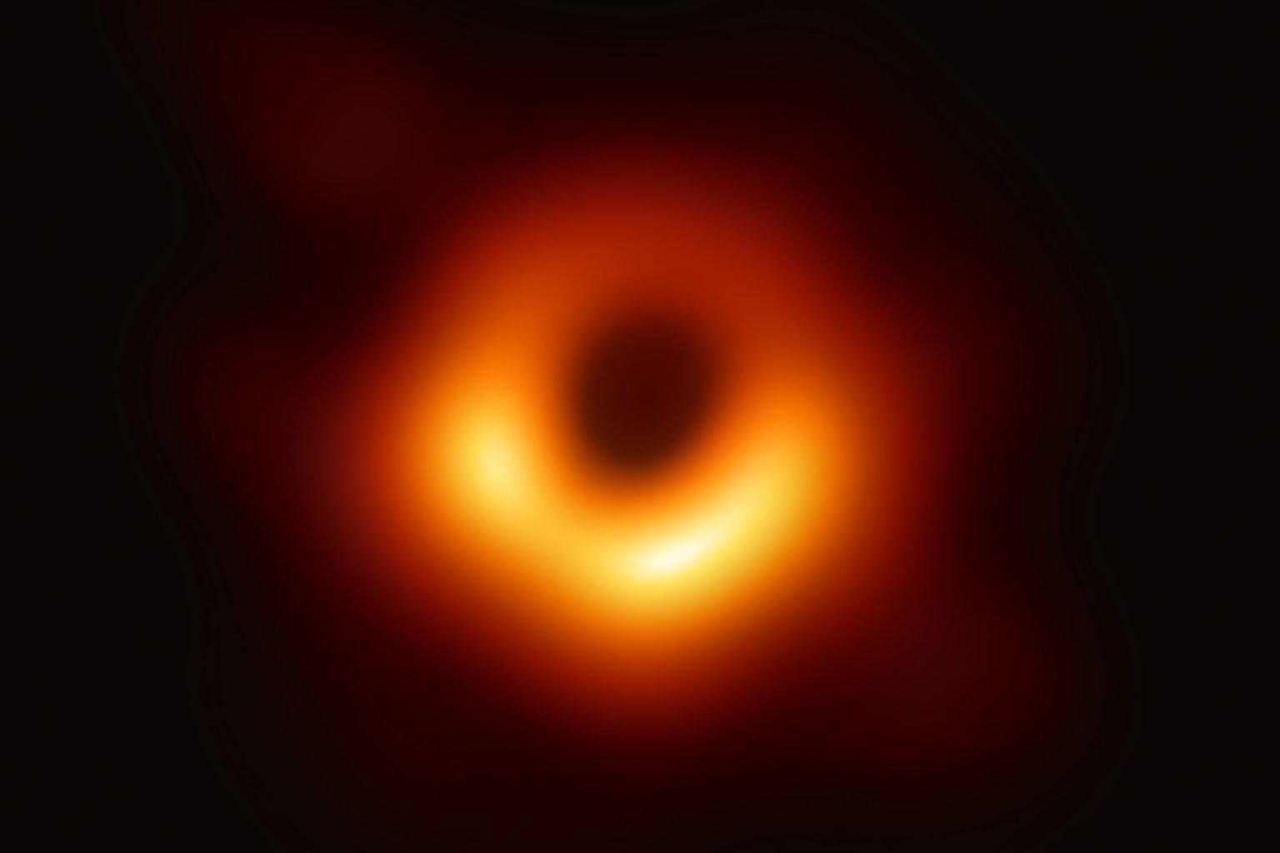In April 2019, the world witnessed a groundbreaking moment in science: the release of the first-ever image of a black hole, captured by the Event Horizon Telescope (EHT). This historic achievement marked the first time humanity was able to "see" the shadow of a black hole, confirming predictions from Einstein’s theory of general relativity in a direct and visual way.
An image of TON 618----------------------------------------------------------------------------------------------------------------------------------
This is the M87 black hole, the first ever image captured of a blackhole………………………………………………………………………..
on APRIL 10th , 2019………………………….
- The image was released on April 10, 2019.
- It showed the supermassive black hole at the centre of the galaxy M87.
- Located about 55 million light-years from Earth.
- The black hole’s mass is about 6.5 billion times that of the Sun.
The EHT is not a single telescope but a global network of radio observatories working together through a technique called Very Long Baseline Interferometry (VLBI). By synchronizing radio data from multiple telescopes around the world—from Hawaii to Antarctica to Spain—scientists effectively created a planet-sized telescope with unprecedented resolution.
- EHT combined 8 radio telescopes worldwide.
- Used VLBI to simulate one Earth-sized telescope.
- Achieved resolution sharp enough to image the black hole's "shadow."
The image revealed a bright, asymmetric ring of light surrounding a dark central region. This shadow is not the black hole itself, but rather the event horizon’s silhouette—the point beyond which no light escapes. The bright ring is formed by superheated gas and dust spiraling into the black hole, glowing in radio wavelengths as it approaches the event horizon.
- The dark centre shows the black hole’s shadow.
- The ring is light from gas orbiting the black hole at near-light speeds.
- Confirms key predictions of black hole structure from general relativity.
This black hole resides in the centre of Messier 87 (M87), a giant elliptical galaxy in the Virgo cluster. It had long been known to host an active galactic nucleus and a massive relativistic jet, making it a strong candidate for the first black hole image. Years of observations and over 5 petabytes of data were processed to produce the final image.
- M87 was chosen for its size and activity.
- The black hole powers a jet extending 5,000 light-years.
- Data processing took over 2 years and involved 200+ scientists.
The success of the EHT project proved that imaging a black hole was not only possible but also scientifically rich. It opened a new era of black hole astrophysics, allowing scientists to measure the mass, spin, and orientation of black holes with far greater accuracy.
- Paved the way for imaging Sagittarius A*, the Milky Way’s black hole.
- Provided new insights into accretion dynamics and relativistic light bending.
- Demonstrated international collaboration in cutting-edge astronomy.
In essence, the first image of a black hole did not just visualize a mysterious object—it validated decades of theoretical work, expanded technological frontiers, and brought black holes from the realm of theory into observable reality.
------------------------------------------
7---BLACK HOLES IN THEORIES OF PHYSICS
-GENERAL RELATIVITY & BLACK HOLES
n 1915, Albert Einstein introduced General Relativity (GR), a theory that redefined the nature of gravity. Instead of being a force acting between masses (as proposed by Newton), gravity was understood as a manifestation of spacetime curvature. Massive objects distort the fabric of spacetime, and this distortion guides how other objects move. In extreme cases, this leads to the formation of black holes—regions of space where gravity is so intense that nothing, not even light, can escape.
- General Relativity describes gravity as curved spacetime.
- Matter and energy bend spacetime geometry.
- Objects move along curved paths (geodesics) defined by this distortion.
GR predicts that very dense masses will cause such intense curvature that they form a singularity, a point of infinite density, surrounded by an event horizon—a boundary beyond which nothing can escape. These are the basic characteristics of black holes, which were predicted as theoretical solutions to Einstein's equations.
- Black holes arise naturally from Einstein’s field equations.
- The event horizon defines the "point of no return."
- Inside lies a singularity where known physics breaks down.

Einstein’s Field Equations and Black Hole Models
Einstein’s Field Equations are the mathematical backbone of General Relativity:
$$R_{μυ}-\left(1/2\right)Rg_{μυ}=8πG/c^{4 }T_{μυ}$$
These equations describe how matter and energy (on the right-hand side) influence the curvature of spacetime (on the left-hand side). In highly symmetrical cases, physicists have derived exact black hole solutions from these equations.
- The Schwarzschild solution describes a static, non-rotating black hole.
- The Kerr solution introduces rotation.
- Charged solutions include Reissner–Nordström and Kerr–Newman black holes.
Schwarzschild Black Holes
The Schwarzschild radius marks the size of the event horizon:
$$R_{s}=\frac{2GM}{c^{2}}$$

- Defines a spherical boundary for the black hole.
- Outside it, gravitational fields are still extreme but light can escape.
- Inside it, all paths lead to the singularity.
_______________________________________________
Kerr Black Holes
Real black holes typically rotate. The Kerr solution adds this rotation and changes the structure of spacetime around them.
- Rotation causes frame dragging—spacetime itself twists.
- The ergosphere is a region outside the event horizon where objects cannot remain still.
- Energy extraction becomes possible through the Penrose process.

Spacetime Effects Around Black Holes
Near black holes, spacetime behaves in ways that defy ordinary experience. General Relativity predicts extreme physical phenomena in these regions.
- Gravitational Time Dilation
Time passes more slowly near massive objects. Near a black hole’s event horizon, time nearly comes to a standstill from a distant observer’s point of view.
- Gravitational Redshift
Light escaping a black hole’s vicinity loses energy, resulting in lower frequencies. This causes the light to appear redshifted.
- Frame Dragging
Near a rotating black hole, the fabric of spacetime is pulled along with its spin. This affects orbits and particle trajectories.
- Geodesic Paths
Objects move along curved spacetime lines. Near a black hole, these paths can spiral inward unless sufficient speed is achieved to escape.
- These effects are most prominent near the event horizon.
- Light itself follows curved paths—gravitational lensing occurs.

Evidence from Observations
Although originally thought to be just a theoretical result, overwhelming observational evidence now confirms black holes’ existence and behaviour.
Observations in Our Galaxy
The centre of the Milky Way hosts a black hole called Sagittarius A*. By tracking the orbits of nearby stars, astronomers measured the mass and size of this central object.
- Mass estimated at ~4 million solar masses.
- Stellar motion confirms intense gravitational pull consistent with GR.
X-Ray Emissions and Accretion
When matter falls into a black hole, it forms a hot, glowing accretion disk. These disks emit X-rays as material is heated to millions of degrees.
- Detected by Chandra and other space telescopes.
- Emissions match predictions from relativistic models of accretion.
Gravitational Lensing
GR predicts that massive objects bend light. Around black holes, this lensing becomes extreme.
- Multiple images, arcs, and rings (Einstein rings) observed.
- Helps measure black hole mass and position.

Event Horizon Telescope (EHT) and Direct Imaging
In 2019, the Event Horizon Telescope captured the first direct image of a black hole in galaxy M87. Using a global network of radio observatories, it imaged the black hole's shadow surrounded by a glowing ring of gas.
- Black hole is 6.5 billion solar masses.
- Located 55 million light-years away.
- Ring structure confirms predictions from General Relativity.
The image matches theoretical simulations based on GR, proving that Einstein's equations hold even under the most extreme gravitational conditions.
- The “shadow” aligns with photon orbit predictions.
- Image resolution achieved through Very Long Baseline Interferometry (VLBI).
- Data processing took 2+ years and involved hundreds of scientists.

Gravitational Waves and Mergers
In 2015, the LIGO detectors observed gravitational waves from two merging black holes. This discovery was monumental, as it provided the first direct evidence of binary black holes and tested General Relativity in strong-field regimes.
- Confirmed black hole masses and spins.
- Signals matched numerical relativity models.
- Opened the field of gravitational wave astronomy.
Subsequent detections have identified dozens of black hole mergers, allowing scientists to test the theory’s accuracy again and again.
- LIGO and Virgo detect black holes up to 90 solar masses.
- Data strengthens GR’s predictions about energy, mass loss, and spacetime deformation.
-------------------------------------

-QUANTUM MECHANICS & THE BLACK HOLE INFORMATION PARADOX
Black holes are one of the most mysterious and fascinating predictions of general relativity. They are formed when a massive star collapses under its own gravity, compressing all of its mass into an incredibly small space. According to classical general relativity, once something crosses the black hole's event horizon, it can never escape. This makes black holes appear to be perfect absorbers—objects that trap everything, including light and information.
However, this idea conflicts with a key principle in quantum mechanics: information is never lost. Quantum theory is governed by unitary evolution, which states that the information about a system’s initial state is preserved over time. This contradiction gives rise to the Black Hole Information Paradox, a puzzle that lies at the intersection of quantum mechanics and general relativity.
- In general relativity, information appears to be destroyed by black holes.
- In quantum mechanics, information must be conserved (unitarity).
- The contradiction between the two frameworks creates the paradox.
Hawking Radiation and Information Loss
In 1974, Stephen Hawking made a groundbreaking discovery: when quantum effects are considered, black holes can emit radiation. Now known as Hawking radiation, this phenomenon arises due to quantum fluctuations near the event horizon. Virtual particle pairs are constantly forming in empty space. If such a pair forms near the event horizon, one particle can fall in while the other escapes, appearing as radiation.
- Hawking radiation is thermal and appears to contain no information about what fell into the black hole.
- Over time, a black hole will evaporate completely, leaving behind only featureless radiation.
- This process implies information destruction, violating quantum principles.
This radiation is purely based on the black hole’s mass, charge, and spin—none of the information about the objects that originally formed or entered the black hole seems to be encoded in it. This directly leads to a paradox.
- The core conflict: How can a physical system destroy information if quantum theory forbids it?
- Black hole evaporation leads to a loss of information about its contents.
- This contradicts the reversibility of quantum processes.

Theoretical Attempts to Resolve the Paradox
Since the discovery of Hawking radiation, many physicists have proposed ideas to resolve the paradox. The goal is to find a theory that merges quantum mechanics with general relativity in a consistent way. Some of the most influential ideas include:
1. The Holographic Principle
First proposed by Gerard 't Hooft and developed by Leonard Susskind, the holographic principle suggests that all the information contained in a volume of space can be described by data on its boundary. For black holes, this means that the information about all objects that fall into the black hole might be stored on the event horizon.
- This principle is mathematically supported by string theory.
- It suggests that the black hole is like a hologram—a 2D surface encoding 3D information.
- This model preserves information and prevents true loss.
2. Black Hole Complementarity
According to this idea, the information is both reflected at the event horizon (for an outside observer) and passes through into the black hole (for an infalling observer). However, no observer can see both events, so there is no contradiction.
- Avoids breaking unitarity.
- Implies that different observers can describe different realities.
3. Firewall Hypothesis
This proposal suggests that a high-energy zone or “firewall” forms at the event horizon, destroying infalling information and breaking the smooth structure of spacetime predicted by general relativity. While this preserves unitarity, it violates the equivalence principle—a key part of relativity.
- Destroys the idea of a smooth horizon.
- Still highly controversial and debated.

New Developments in Quantum Information Theory
Recent breakthroughs from 2019 onward have brought significant progress. Researchers used tools from quantum information theory to analyse how information might be encoded in Hawking radiation. Using concepts like entanglement entropy and replica wormholes, they found evidence that:
- Information is not lost, but gradually leaks out with the radiation.
- After a certain time, called the Page time, radiation begins to carry encoded information.
- The final Hawking radiation contains all the information about the initial black hole.
These studies used the quantum extremal surface method, which identifies where information is stored in spacetime. Calculations showed that black holes emit radiation in a unitary manner, meaning information is preserved after all.
- Supports the idea that Hawking’s original calculation missed subtle correlations in the radiation.
- Helps bridge the gap between quantum mechanics and gravity.
- Suggests black hole evaporation is consistent with quantum unitarity.

Potential Resolutions and Outlook
Several competing theories continue to be explored:
- Quantum Tunnelling Models – Suggest that radiation is not perfectly thermal, and tiny quantum corrections allow information to leak out slowly.
- Remnants Hypothesis – Black holes may leave behind small, stable leftovers that contain all the original information. However, this idea raises problems with infinite varieties of remnants.
- Gravitational Holography – Based on the ADS/CFT correspondence, it proposes that everything that happens in a gravity-based bulk universe is mirrored in a lower-dimensional quantum field theory without gravity.
These theories suggest that a complete understanding of black holes will require a full theory of quantum gravity, possibly involving string theory, loop quantum gravity, or entirely new physics. While the paradox hasn’t been definitively resolved, most modern physicists believe that information is ultimately preserved, and the resolution lies in how we interpret black hole radiation and spacetime itself.
- The paradox has deep implications for the nature of space, time, and reality.
- It continues to guide research into the unification of physics.
-------------------------------------
-ROLE OF BLACK HOLES IN SPACE-TIME STRUCTURE
Black holes are not merely dense, dark regions of space—they are dynamic objects that influence the very structure of space-time. According to Albert Einstein’s theory of General Relativity, massive objects cause space-time to curve. Black holes, with their immense mass and density, create such extreme curvature that they significantly reshape the local geometry of space and time. They are essential tools for understanding gravity and the fundamental structure of the universe.
A black hole is defined by its event horizon, a boundary beyond which no matter, light, or information can escape. Within this boundary lies the singularity, a point of infinite density where known laws of physics break down. These two features—event horizon and singularity—mark the most extreme expressions of space-time curvature known in physics.
- Black holes serve as solutions to Einstein’s field equations.
- They cause extreme warping of both space and time.
- They play a major role in defining causality and information flow in the universe.

Curvature of Space-Time
Einstein’s field equations describe how mass and energy determine the curvature of space-time. A black hole’s mass is so concentrated that the curvature becomes near-infinite at the singularity. The closer an object gets to a black hole, the stronger the curvature.
Near a black hole, space is severely warped, and time behaves abnormally. This extreme curvature affects everything from the paths of light rays to the flow of time for observers at different distances from the black hole. These predictions have been confirmed through observations like gravitational lensing and time dilation near massive bodies.
- Black holes create a steep gravitational well in space-time.
- Clocks run slower near a black hole than far away (gravitational time dilation).
- Matter falling into a black hole experiences tidal forces due to the gradient in curvature.
This behaviour illustrates the profound impact of black holes on the fundamental fabric of the universe.

Event Horizons and Causal Structure
One of the most significant ways black holes influence space-time is by changing its causal structure. The event horizon is a boundary beyond which events cannot affect an external observer. Once something crosses the event horizon, it is lost to the outside universe.
From the viewpoint of general relativity, this boundary divides the universe into two regions with fundamentally different causal properties. The inside of a black hole becomes disconnected from the rest of the universe.
- The event horizon acts as a causal boundary in space-time.
- All future-directed paths inside the event horizon lead to the singularity.
- Outside observers can never observe what happens beyond the event horizon.
This alters the flow of information and energy, making black holes a critical part of the study of causality in physics.

Rotating Black Holes and Frame Dragging
In the real universe, most black holes rotate. These are described by the Kerr solution to Einstein’s equations. Rotating black holes twist space-time around them, a phenomenon known as frame dragging.
In this scenario, the space-time around the black hole is dragged in the direction of its rotation. This effect becomes so strong near the black hole that even objects at rest appear to be moving. The region where this occurs is known as the ergosphere.
- In the ergosphere, space-time is twisted along with the black hole.
- Frame dragging affects the orbits of matter and light.
- Energy can be extracted from a rotating black hole (Penrose process).
Rotating black holes show that space-time is not just curved—it can also be twisted and dynamic due to angular momentum.

Black Holes as Topological Features
Black holes aren’t just objects embedded in space-time—they are topological features of the geometry itself. They represent regions where the curvature and structure of space-time are fundamentally altered. Theoretical tools such as Penrose diagrams help visualize how space-time behaves around black holes.
Black holes can also create trapped surfaces, regions where light rays are forced to converge inward. These features are critical in understanding the global structure of space-time and play a key role in mathematical theorems about the behaviour of gravitational systems.
- Penrose diagrams depict the entire causal history of a black hole.
- Trapped surfaces define the boundary between ordinary space and collapsed regions.
- Black holes define non-trivial topologies that alter space-time’s shape and behaviour.
These geometrical characteristics show that black holes are not simply holes in space—they are rich, active components of the space-time fabric.

Impact on Cosmology and the Universe
Black holes influence not just local regions of space but also have a significant role in the cosmological structure of the universe. Supermassive black holes at the centres of galaxies may help shape galaxy formation and behaviour. Their gravitational pull regulates star orbits and interstellar matter distributions.
Additionally, black holes offer clues to the early universe, where densities and curvatures may have been similar to those inside black holes. Studying them can provide insight into the origin of space-time, and their extreme conditions help test theories of quantum gravity.
- Supermassive black holes anchor galaxies and influence star formation.
- Black holes provide a bridge between cosmology and particle physics.
- They offer a way to explore the unification of gravity and quantum mechanics.
In many ways, black holes are the key to unlocking the ultimate structure of space-time.
- and by this we can understand that
- Black holes are intense sources of space-time curvature.
- They create event horizons, altering the causal layout of the universe.
- Rotating black holes demonstrate frame dragging, showing space-time’s dynamic nature
.
- They help define the global structure and topology of the universe.
- Black holes influence galactic dynamics and may hold the key to quantum gravity.
-------------------------------------
8---BLACK HOLES IN ASTROPHYSICS & COSMOLOGY
-BLACK HOLES AS SOURCE OF HIGH ENERGY RADIATION
black holes are not simply dark objects in space. In fact, they are among the most energetic phenomena in the universe. While light cannot escape from within the event horizon of a black hole, the region around it, known as the accretion disk, can emit extremely high-energy radiation. Black holes are thus powerful sources of high-energy radiation, contributing significantly to our understanding of astrophysical processes and the behaviour of matter and energy under extreme conditions.
- The key mechanism behind this high-energy radiation is the accretion of matter onto the black hole. As matter falls into the black hole, it forms a rapidly spinning disk, heated by friction and gravitational forces. The intense radiation from this disk and the jets launched from the poles of the black hole can produce energy across the entire electromagnetic spectrum, including X-rays and gamma rays.
- Accretion disks around black holes are key sources of high-energy radiation.
- Matter falling toward a black hole is heated to extreme temperatures as it spirals inward.
- The black hole’s rotational energy and gravitational forces power relativistic jets that emit radiation.

Mechanisms of High-Energy Radiation
- High-energy radiation from black holes is generated through several processes, most notably the formation of accretion disks and the relativistic jets ejected from the poles of black holes. These processes are the result of complex interactions between matter and the intense gravitational field of the black hole.
Accretion Disks and X-ray Emission
- An accretion disk forms when matter—usually gas and dust from a companion star—falls toward a black hole. As the material spirals inward, it heats up to incredibly high temperatures due to friction between particles in the disk. This process causes the disk to emit a broad spectrum of radiation, including visible light, ultraviolet, and X-rays.
- X-ray emission: The inner regions of the accretion disk are heated to millions of degrees, emitting high-energy X-rays.
- The inner edge of the disk can emit relativistic X-rays, which are crucial for studying black hole dynamics.
- As matter reaches the event horizon, it is no longer visible. However, the X-rays emitted from just outside the event horizon provide vital clues to the presence of the black hole.
- Relativistic Jets and Gamma-Ray Emission
- In addition to the accretion disk, black holes can launch relativistic jets—narrow beams of particles that move at nearly the speed of light. These jets are primarily composed of ionized gas, which can interact with magnetic fields and surrounding matter. As these particles are accelerated, they emit radiation, including gamma rays, the highest-energy form of electromagnetic radiation.
- Relativistic jets are powered by the black hole’s rotational energy and the accretion process.
- Jets can extend across vast distances, sometimes stretching millions of light-years from the black hole.
- The jets emit radiation in the radio through gamma-ray spectra, depending on the energy of the particles.
- The high-energy radiation produced by relativistic jets is one of the most significant sources of gamma rays in the universe.

Types of High-Energy Radiation from Black Holes
- Black holes are capable of emitting radiation across the full spectrum, but they are especially noted for producing X-rays and gamma rays. These high-energy photons arise from the complex interactions between matter and radiation near the black hole.
-------------------------------------
X-ray Radiation
- The intense gravitational forces around a black hole, particularly near the event horizon, generate X-ray radiation through a combination of heating and compression of matter. X-ray telescopes, like the Chandra X-ray Observatory and XMM-Newton, have provided critical data about black holes by detecting the X-rays emitted from their accretion disks.
- X-ray binaries: Systems in which a black hole is paired with a normal star can be identified by the X-ray emission caused by material from the star falling into the black hole.
- Relativistic X-rays: These come from regions close to the event horizon and carry important information about the black hole’s mass, spin, and accretion dynamics.
- Gamma-ray Radiation
- Gamma rays are the most energetic form of electromagnetic radiation and are produced by black holes primarily through processes involving their relativistic jets. As particles within the jets accelerate to nearly the speed of light, they collide with other particles, producing gamma rays. Gamma-ray telescopes like Fermi and HESS have observed these high-energy emissions, providing direct evidence for the high-energy environments near black holes.
- Blazars, a subclass of active galactic nuclei (AGN), are among the most powerful gamma-ray emitters. These AGNs host supermassive black holes and exhibit extremely bright, variable gamma-ray emission.
- Gamma-ray bursts (GRBs), which are thought to be linked to the formation of black holes, also release enormous amounts of energy.

Observational Evidence and Famous Black Holes
- Several black holes have been observed emitting high-energy radiation, providing direct evidence for their role as sources of extreme energy.
- Cygnus X-1
- Cygnus X-1 is one of the first black hole candidates discovered through its X-ray emission. It is part of a binary system where matter from a companion star is falling into the black hole, forming an accretion disk. The system emits strong X-rays, making it a prime example of a stellar-mass black hole generating high-energy radiation.
- Cygnus X-1 is one of the most studied black holes, offering key insights into the accretion process and X-ray emissions.
- Sagittarius A*
- At the centre of our own Milky Way galaxy lies a supermassive black hole known as Sagittarius A*. This black hole is not actively accreting as much material as some other black holes, but it still emits a significant amount of radiation, including X-rays and radio waves. The radiation from Sagittarius A* is thought to be due to material falling into the black hole, although its activity level is relatively low compared to more active black holes.
M87 and the Event Horizon Telescope
- The black hole at the centre of the galaxy M87, imaged by the Event Horizon Telescope (EHT) in 2019, provides an example of how black holes can emit high-energy radiation from their jets. The black hole’s relativistic jets are associated with radiation across the electromagnetic spectrum, from radio to gamma rays.
- M87 is a supermassive black hole, and its jets are among the most energetic sources of radiation known.

Conclusion and Future Directions
- Black holes, particularly those that actively accrete matter or host relativistic jets, are powerful sources of high-energy radiation. This radiation provides a wealth of information about the processes occurring near black holes, including how matter behaves under extreme gravitational conditions and how energy is emitted at relativistic speeds.
- Black holes continue to be essential in understanding high-energy astrophysical phenomena.
- The study of high-energy radiation emitted by black holes is central to astrophysical research.
- Ongoing advancements in space telescopes and observational technologies will provide more detailed insights into black hole behaviour and their role in cosmic radiation.
-------As we continue to study black holes, their role as sources of high-energy radiation will remain one of the most fascinating aspects of modern astrophysics, offering a window into some of the most extreme conditions in the universe.------------------
-------------------------------------------------------------
-THEIR ROLE IN GALAXY FORMATION
Black holes, especially supermassive black holes (SMBHs), are not isolated cosmic anomalies but play a central role in the formation and development of galaxies. Over the past few decades, research has revealed a powerful and complex relationship between black holes and the galaxies that host them. Far from being passive entities, black holes influence everything from star formation rates to galaxy shape and size, and even the large-scale structure of the universe.
Although black holes were once considered end-points of stellar evolution, scientists now view them as regulators and architects of galactic structure. Their gravitational dominance, energy output, and interactions with surrounding matter all contribute to shaping their host galaxies from early stages of development through billions of years of cosmic evolution.
- Supermassive black holes lie at the centre of most massive galaxies.
- Their presence is tied closely to galactic mass, structure, and star formation activity.
- They regulate and sometimes halt star formation through processes known as AGN feedback.

-How Black Holes and Galaxies Form Together?
The origin of this relationship likely begins during the early universe, shortly after the Big Bang. Galaxies begin to form as massive gas clouds collapse under gravity. Simultaneously or soon after, seed black holes form—possibly from the collapse of massive stars or direct collapse of dense gas. These black holes then grow rapidly, feeding on gas and merging with others during galaxy collisions.
- Seed black holes likely formed within the first billion years of the universe.
- As galaxies grew through mergers and accretion, so did their central black holes.
- This mutual growth process is called co-evolution.
It appears that the growth of galaxies and black holes are deeply interconnected, as data shows that the mass of the SMBH at a galaxy’s centre often correlates with the galaxy’s bulge mass and star velocity dispersion. This surprising consistency implies a feedback loop where the black hole and galaxy influence each other’s development.

-Influence on Star Formation and Gas Regulation
Supermassive black holes influence star formation in galaxies through processes collectively referred to as AGN (Active Galactic Nucleus) feedback. When matter spirals into a black hole, it forms a hot, luminous accretion disk, emitting intense energy and sometimes launching jets.
This feedback can either:
- Suppress star formation by heating up or expelling the gas needed to form stars.
- Or, in some cases, trigger localized star formation by compressing gas clouds.
Key Effects:
- Negative feedback: Prevents runaway star formation by pushing gas out or heating it so it can’t collapse into stars.
- Positive feedback (less common): AGN outflows compress gas in some regions, possibly initiating star formation.
- AGN winds and relativistic jets can travel across the galaxy, influencing the interstellar medium far from the black hole itself.
In massive galaxies, this regulatory process helps prevent the formation of too many stars, maintaining a balance between growth and energy output.

-Shaping the Structure of Galaxies
The morphology of galaxies—whether spiral, elliptical, or irregular—is partly determined by black hole activity. Feedback from the central black hole influences how stars and gas are distributed, especially in the inner regions of a galaxy.
- Elliptical galaxies tend to have large, dormant black holes and little cold gas—suggesting earlier periods of intense AGN feedback that quenched star formation.
- Spiral galaxies often show moderate AGN activity, allowing continued star formation, especially in their disks.
Moreover, galactic mergers—which are common over cosmic timescales—can trigger both bursts of star formation and black hole feeding. During such mergers, black holes can:
- Sink to the centre of the merged galaxy via dynamical friction.
- Eventually merge, forming a larger SMBH and releasing gravitational waves.
These events can radically transform a galaxy’s structure, sometimes turning two spirals into a single elliptical galaxy.

-Relationship Between Black Hole Mass and Galaxy Properties
One of the strongest pieces of evidence for the black hole-galaxy connection is the correlation between SMBH mass and the properties of their host galaxies, such as:
- Bulge mass
- Velocity dispersion of stars
- Luminosity of the galactic centre
This is known as the M-sigma relation, and it implies that:
- The mass of the black hole is not random but scales with how massive and concentrated the galaxy is.
- Black holes and galaxies evolve in tandem, possibly through shared growth mechanisms.
This relationship also suggests that black holes may help regulate how large galaxies become.

-Impact Beyond the Host Galaxy
Black holes don’t just influence their immediate surroundings; they can affect entire galactic environments. In galaxy clusters, the central galaxy often hosts an enormous black hole whose feedback heats surrounding gas in the cluster, affecting multiple galaxies.
- Jets and radiation from these black holes can stop cooling of hot gas across millions of light-years, halting new galaxy formation.
- This widespread influence helps maintain the structure of the cluster and prevents unchecked star formation.
The powerful reach of black holes highlights their role as cosmic thermostats, controlling not only their own galaxy’s fate but also that of many nearby ones.
--------------------------------

-DARK MATTER & BLACKHOLES-
exploring the connection……..
Dark matter and black holes are two of the most mysterious components of the universe, each invisible to direct observation yet essential to our understanding of cosmic structure and evolution. While black holes are compact regions of space with gravitational pulls so intense that not even light can escape, dark matter is a form of matter that does not emit, reflect, or absorb light, but is believed to make up roughly 85% of the universe’s matter content. Over time, scientists have begun to explore whether these two phenomena might be related or even connected in origin.
- Black holes and dark matter are both invisible yet detectable through their gravitational effects.
- Researchers are exploring whether black holes could account for all or part of the dark matter.

-Primordial Black Holes: A Dark Matter Candidate
One of the most discussed theories linking dark matter and black holes is the idea of primordial black holes (PBHs). These are hypothetical black holes that could have formed in the early universe due to extremely dense fluctuations in space. Unlike black holes formed from collapsing stars, PBHs could have a wide range of masses, from tiny ones to those much larger than the Sun.
If enough PBHs were created during the early moments after the Big Bang, they could act just like dark matter by clustering and interacting only through gravity.
- Primordial black holes may have formed just after the Big Bang, not from dying stars.
- They are invisible, massive, and long-lived—qualities needed for a dark matter candidate.
Scientists have searched for signs of PBHs through various observations, including gravitational lensing events and gravitational wave detections, but no conclusive evidence has yet been found.

-Shared Gravitational Effects in Galaxies
Both dark matter and black holes influence galaxies through gravity. While black holes impact the central regions of galaxies, dark matter is spread out in large halos that envelop entire galaxies. Observations of how stars rotate around galactic centres suggest the presence of far more mass than can be seen — mass attributed to dark matter.
- Dark matter forms halos that surround galaxies and prevent them from flying apart.
- Black holes dominate the inner core gravitational field but not on galaxy-wide scales.
Although black holes can explain gravitational effects in very small regions, they cannot account for the distribution of mass needed to explain dark matter’s effects across a galaxy or galaxy cluster. This key distinction makes it unlikely that regular black holes alone are the solution to the dark matter mystery.

-Feedback and Structure Formation
Despite their scale differences, black holes and dark matter may both influence the formation of structure in the universe. Supermassive black holes found at the centres of galaxies can eject huge amounts of energy and matter, affecting star formation and the shape of galaxies. Meanwhile, dark matter serves as the scaffolding on which galaxies form, pulling gas into regions where stars and galaxies are born.
- Dark matter pulls in ordinary matter, helping galaxies form and cluster.
- Black holes can heat and expel gas, slowing or stopping star formation in galaxies.
There may be a feedback relationship where dark matter helps gather matter into galaxies, and black holes influence how that matter behaves over time.

-The Mysterious Co-Evolution
Data from observations show a surprising correlation between the mass of supermassive black holes and the properties of their host galaxies, including the amount of dark matter they contain. This has led some researchers to suspect that black holes and dark matter halos may co-evolve—growing in tandem as galaxies form and merge over billions of years.
- The mass of a galaxy’s black hole often matches the mass of its dark matter halo.
- This hints at a deeper link between dark matter distribution and black hole growth.
However, the exact mechanism of this connection remains unclear. It’s unknown whether dark matter actively helps feed black holes, or if their growth is simply a parallel process driven by galactic evolution.

-Gravitational Wave Clues and Microlensing
Modern observational tools like gravitational wave detectors (e.g., LIGO, Virgo) and gravitational microlensing surveys provide new ways to test the connection between black holes and dark matter. Mergers of small black holes detected via gravitational waves could point to a population of PBHs, while microlensing events caused by dark objects may help us detect them directly.
- Gravitational wave detections may be picking up signals from ancient primordial black holes.
- Gravitational lensing can help detect hidden black holes in dark matter-dense regions.
These tools are essential for testing whether black holes truly make up some portion of the dark matter content in the universe.

-Challenges and Counterarguments
Despite the intriguing ideas, there are several challenges to the theory that black holes could explain dark matter. Observations from the early universe (such as the cosmic microwave background) place strong limits on how many black holes could exist without disrupting known patterns. In addition, simulations of galaxy formation with PBH-based dark matter don’t always match observed structures.
- Cosmic microwave background limits how much mass could be tied up in early black holes.
- Galaxy structure simulations with PBHs don’t always fit real-world data.
Furthermore, dark matter appears to be "cold" and diffuse, whereas black holes are compact and massive. This makes it difficult for black holes to behave like the dominant form of dark matter expected by cosmological models.
Although we do not yet have proof that black holes and dark matter are directly related, the possibility continues to drive new research. Primordial black holes remain one of the few viable non-particle dark matter candidates. And the fact that dark matter and black holes both play major roles in shaping the universe makes their relationship a key focus of astrophysics.
- Black holes are not the main explanation for dark matter—but may still contribute.
- Primordial black holes remain a potential solution still under investigation.
-------------------------------------
9---CAN BLACK HOLES BE HARNESSED FOR ENERGY?
Yes—in theory, black holes could be harnessed for energy, and several ideas have been proposed based on physics, though none are currently feasible with today’s technology. Here’s a detailed explanation in paragraph form with important points highlighted as bullet points, suitable for a school report or presentation:

Black holes are among the most powerful objects in the universe, capable of releasing immense amounts of energy through various processes. Scientists have long speculated whether this energy could one day be harnessed by an advanced civilization. While these ideas are currently theoretical, they are grounded in physics and have been explored in scientific literature.
Hawking Radiation and Black Hole Evaporation
One of the most well-known theoretical mechanisms of black hole energy release is Hawking radiation, a quantum process by which black holes slowly emit particles and lose mass over time. Although this radiation is incredibly weak for large black holes, smaller ones (especially hypothetical micro black holes) could emit more intense radiation.
- Hawking radiation allows black holes to emit energy and eventually evaporate.
- Harnessing this radiation could, in theory, provide an energy source.
Capturing Hawking radiation for energy, however, would require extremely small black holes and technology far beyond our current capabilities.

-The Penrose Process: Rotating Black Holes
For rotating black holes (Kerr black holes), there exists a region outside the event horizon called the ergosphere, where space-time itself is dragged by the black hole’s spin. The Penrose process, proposed by Roger Penrose in 1969, shows that energy can be extracted from this ergosphere.
- The Penrose process allows particles to split in the ergosphere, with one falling in and the other escaping with extra energy.
- This could be used to extract energy from a spinning black hole.
While highly efficient in theory, this method also presents major engineering challenges, such as delivering and retrieving particles at near-light speed near an object of extreme gravity.

-Black Hole Accretion Disks
Another practical concept involves accretion disks, the hot, swirling matter spiraling into a black hole. These disks can emit vast amounts of electromagnetic radiation, including X-rays, as gravitational energy is converted to heat and light.
- Accretion disks around black holes can radiate more energy per mass than nuclear fusion.
- Tapping into this emitted radiation could offer immense energy returns.
Some scientists compare this to a cosmic power plant, where gas falling into a black hole is like fuel releasing energy far more efficiently than any Earth-based source.

-Dyson Spheres Around Black Holes
A very speculative idea is building a Dyson sphere around a black hole instead of a star. The Dyson sphere would collect energy from Hawking radiation or from accretion disk emissions.
- A Dyson sphere could capture radiation from a black hole, especially if it’s actively feeding.
- This is a possible method for advanced civilizations ( Type II or III on the Kardashev scale ) to extract energy.
This concept pushes the limits of imagination and engineering, but it offers a glimpse into how black holes could be used in an energy-harvesting role.

-Black Hole Bombs and Advanced Concepts

Physicist Yakov Zel'dovich and later researchers proposed theoretical mechanisms where energy could be amplified around a spinning black hole using mirrors or fields, creating a kind of “black hole bomb.” This is based on super radiance, where waves are reflected and amplified between the ergosphere and a surrounding mirror.
- Super radiance could theoretically extract large amounts of energy from black holes.
- The "black hole bomb" idea is speculative but grounded in general relativity and wave physics.
This process remains purely theoretical but could be a way to maximize energy extraction without direct matter interactions.

From the understanding of this, we can say that black holes are not only destructive forces, but also cosmic energy sources………
If humanity ever develops the ability to manipulate blackholes easily and safely, they can be used as some of the most powerful energy sources in our universe!!
but currently we are not even type I civilisation in the Kardashev scale, so at the present, these methods of harnessing energy from black holes are just but theories……
-------------------------------------
-WORMHOLES & SPACE TRAVEL THEORIES
Wormholes, also known as Einstein-Rosen bridges, are theoretical tunnels through space-time that could connect distant parts of the universe—or even different universes entirely. The idea comes from solutions to Einstein's field equations of general relativity, which allow for the bending and warping of space-time under the influence of mass and energy. While they remain hypothetical, wormholes have fascinated both physicists and science fiction writers for decades due to their potential to make faster-than-light space travel a reality.
- Wormholes are theoretical shortcuts through space-time that could connect two distant regions.
- They are based on valid mathematical solutions to Einstein’s equations but have never been observed.

-Origins in General Relativity
The concept of a wormhole was first explored by Albert Einstein and physicist Nathan Rosen in 1935. They proposed a structure now called an Einstein-Rosen bridge, which mathematically connects two black holes. This solution suggested that it might be possible for particles to travel through a tunnel-like bridge in space-time, skipping the normal space between two distant points.
Later, in the 1980s, physicists like Kip Thorne and Michael Morris expanded on this idea, proposing traversable wormholes—wormholes that could be safely crossed by a human or spacecraft.
- Einstein-Rosen bridges are the first mathematical models of wormholes.
- Modern theories suggest that wormholes could be traversable if exotic matter is used.

-Exotic Matter and Stability
The major problem with wormholes is their instability. According to general relativity, a natural wormhole would collapse too quickly for anything to pass through. However, theorists propose that the tunnel could be kept open using exotic matter—a substance with negative energy density and negative pressure.
Such matter doesn’t exist in known quantities, but quantum field theory allows for the existence of negative energy under certain conditions, such as in the Casimir effect.
- Wormholes would require exotic matter to stay open and be usable.
- Exotic matter has negative energy, which counteracts gravitational collapse.
If exotic matter could be created or discovered, it might allow for the construction or stabilization of a wormhole, turning a theoretical concept into a usable cosmic shortcut.

-Faster-Than-Light Travel and Relativity
Wormholes theoretically allow for faster-than-light travel not by exceeding the speed of light, but by shortening the path between two points in space. In this way, a traveller could arrive at a distant location much faster than light would if it travelled through normal space.
- Wormholes bypass space rather than violate light-speed limits.
- They offer a way to travel vast cosmic distances in short time frames.
This idea preserves Einstein’s limit on local speed but redefines the geometry of the journey, enabling what might be perceived as instantaneous travel across galaxies or even between universes.

-Time Travel Possibilities
One of the more controversial aspects of wormholes is that they might allow time travel. If one mouth of a wormhole moves at high speed or sits in a stronger gravitational field (due to time dilation), time would pass at different rates for each end. This could, in theory, allow a traveller to move backward or forward in time relative to the starting point.
- Wormholes could function as time machines if one mouth experiences time more slowly.
- This raises paradoxes and challenges such as causality violations.
The idea of using wormholes for time travel brings up serious issues with causality, such as the "grandfather paradox," and many physicists believe that unknown laws of quantum gravity would prevent such paradoxes from occurring.

-Detection and Feasibility
Despite being widely accepted in theoretical physics, no wormholes have ever been detected. Because they are predicted to be extremely small (on the quantum scale), locating a natural wormhole would be extremely difficult. Some theories suggest they could appear near black holes or dark matter regions.
- No observational evidence of wormholes exists as of now.
- They may exist on microscopic scales or in regions of high gravity.
Scientists have suggested that gravitational waves or unusual gravitational lensing patterns might one day offer clues to the existence of wormholes. Advanced instruments like the Event Horizon Telescope or next-generation gravitational wave detectors could help identify anomalies consistent with wormhole signatures.

-Wormholes in Theoretical Physics
In modern physics, wormholes play a major role in quantum gravity and string theory. Some researchers believe that microscopic wormholes could form naturally at the quantum level and play a role in entanglement and information transfer.
- The ER=EPR conjecture suggests wormholes could link entangled particles.
- This connects wormholes to quantum mechanics and black hole information theories.
In this view, the universe could be far more interconnected than previously thought, and wormholes might be fundamental building blocks of space-time itself.

-Wormholes and Advanced Civilizations
In theoretical discussions about advanced extraterrestrial civilizations, wormholes are often cited as a possible method of interstellar transportation. A Type II or Type III civilization on the Kardashev scale might possess the energy and technological means to stabilize wormholes or construct artificial ones.
- Wormholes could be used by highly advanced civilizations for galactic travel.
- These civilizations would need mastery over space-time and energy control.
This has led to speculation that unusual astrophysical observations might not just be natural phenomena but could hint at intelligent manipulation of space-time.
The ideology of wormholes as a means of space-time travel is one of the most fascinating topics in theoretical physics……
-but there are no evidences which prove or support their existence
They remain a promising concept for faster than light-travel,
time-manipulation & universal connectivity
They represent a frontier of what could be possible with future discoveries in physics, quantum mechanics & cosmic engineering
-------------------------------------------------------------
-UPCOMING BLACK HOLE STUDIES & MISSIONS
Black holes remain among the most mysterious and fascinating objects in the universe. While major breakthroughs such as the first image of a black hole have already been achieved, future missions and scientific studies are poised to uncover even deeper insights. Over the next decade, astronomers and physicists plan to probe the structure, behaviour, and evolution of black holes using cutting-edge telescopes, space missions, and theoretical models. These efforts aim not only to understand black holes more thoroughly, but also to test fundamental physics such as general relativity, quantum gravity, and the nature of space-time itself.
- The coming decade will see unprecedented studies of black holes across multiple wavelengths and techniques.
- New missions will enhance our understanding of black hole formation, growth, and role in galaxy evolution.

-Next-Generation Event Horizon Telescope ( ngEHT )
Following the success of the Event Horizon Telescope (EHT) in capturing the first image of a black hole (M87*) in 2019, scientists are now working on the next-generation EHT, which will offer higher resolution and faster imaging. This involves increasing the number of radio telescopes around the world and improving their synchronization.
The ngEHT will allow researchers to create black hole "movies" showing the dynamic motion of matter in the accretion disk and the evolution of relativistic jets in real-time.
- ngEHT aims to capture dynamic, time-lapse images of black holes.
- It will help study the event horizon, plasma flows, and magnetic fields near black holes.
The improved array may also target the black hole at the centre of the Milky Way (Sagittarius A*) more precisely, offering insight into nearby supermassive black holes.

-LISA: The Laser Interferometer Space Antenna
Set to launch in the mid-2030s by the European Space Agency (ESA) with NASA collaboration, LISA will be the first space-based gravitational wave observatory. Unlike Earth-based detectors like LIGO and Virgo, LISA will be sensitive to lower-frequency gravitational waves, especially from supermassive black hole mergers.
- LISA will detect gravitational waves from colliding black holes millions of times more massive than the Sun.
- It will provide insight into how black holes merge and how galaxies grow.
LISA will open a new window into black hole astrophysics by allowing astronomers to observe black holes across the entire observable universe, including the early cosmic epochs.

-James Webb Space Telescope (JWST) Observations
While the JWST is not exclusively focused on black holes, it plays a key role in observing the formation and growth of early supermassive black holes. With its infrared capabilities, JWST can peer through cosmic dust and view the light from the first black holes forming just a few hundred million years after the Big Bang.
- JWST helps trace the origin of the universe’s first black holes and their host galaxies.
- It offers high-resolution spectra to study black hole feeding and the surrounding environment.
JWST's discoveries are expected to reshape our understanding of how black holes formed so early and became as massive as we observe them today.

-Athena X-ray Observatory (ESA, ~2035)
ESA’s Advanced Telescope for High-Energy Astrophysics (Athena) will be the most powerful X-ray observatory ever built. It is designed to study accretion processes, black hole feedback, and the environment around supermassive black holes with unmatched clarity.
Athena will allow astronomers to measure how matter falls into black holes and how energy is ejected back into galaxies.
- Athena will study the feeding mechanisms of black holes in unprecedented detail.
- It will help understand how black holes influence galaxy formation and evolution.
The mission is also expected to map the cosmic web—the large-scale structure of the universe shaped partly by black hole outflows.

-Einstein Probe (China, 2025 launch)
China’s Einstein Probe is an upcoming X-ray observatory focused on detecting transient high-energy events, including tidal disruption events (TDEs)—which occur when stars get too close to black holes and are torn apart.
The Einstein Probe will feature wide-field and deep X-ray imaging, providing a constant monitor for new black hole activity across the sky.
- Einstein Probe will detect new black hole outbursts and accretion events.
- It will improve understanding of how black holes consume stellar material.
This will be crucial for understanding how black holes interact with their environment in real time.

-XRISM (X-ray Imaging and Spectroscopy Mission)
A joint mission by JAXA (Japan), NASA, and ESA, XRISM is scheduled to launch in the mid-2020s. It will study X-rays from hot gases around black holes with high-resolution spectroscopy.
XRISM is expected to:
- Reveal the structure and dynamics of black hole surroundings using precision X-ray measurements.
- Help analyse the impact of black hole jets and winds on galactic environments.
XRISM will work as a precursor to the Athena mission, offering early high-resolution data for astrophysical models.

-THESEUS Mission
The Transient High-Energy Sky and Early Universe Surveyor (THESEUS) is a proposed ESA mission that would track gamma-ray bursts and early black hole activity, particularly from the early universe.
Its goal is to study the connection between star formation, black hole births, and the evolution of the cosmic structure shortly after the Big Bang.
- THESEUS would provide insight into the first generation of stellar-mass black holes.
- It links black hole formation to the evolution of the first stars and galaxies.

-Theory and Simulation Efforts
Alongside observational missions, computational astrophysics is advancing rapidly. Supercomputers and AI models are simulating black hole mergers, relativistic jets, and quantum effects at the event horizon. These simulations are helping researchers interpret data from observatories and refine theoretical models.
- Simulations now allow visualization of black hole environments and test predictions of general relativity.
- They also aid in preparing observation strategies for missions like LISA and Athena.

-The Future: Artificial Detection and Exotic Physics
Future missions may not only study traditional black holes but also investigate primordial black holes, quantum black holes, or test hypotheses such as extra dimensions and holographic principles.
- New missions may detect exotic black holes that challenge current physics.
- This could reveal links between gravity, quantum theory, and dark matter.
Scientists are also developing algorithms to analyse anomalous gravitational signals, hoping to spot clues of phenomena beyond standard black hole theory.
These upcoming missions and theoretical efforts are poised to revolutionize our understanding of black holes in the next two decades. With advancements in gravitational wave astronomy, high-resolution imaging, and space-based X-ray observation, the future of black hole studies promises to reveal insights into the origin, growth, and cosmic impact of these enigmatic objects……..
-------------------------------------
10---CONCLUSION
-SUMMARY OF KEY POINTS
Black holes, once regarded as mere theoretical predictions, have transformed into a central focus of modern astrophysics and cosmology. Their study touches nearly every major question in physics—from the structure of space-time and the behaviour of matter under extreme conditions to the fate of galaxies and even the fundamental nature of information in the universe. Throughout this report, various aspects of black holes have been examined, including their properties, formation, interaction with surrounding matter, and roles in the universe’s large-scale structure.
At their core, black holes are regions of space where gravity becomes so intense that nothing—not even light—can escape. The event horizon marks the boundary beyond which escape is impossible, and at the very centre lies the singularity, a point of infinite density where known physics breaks down.
- Black holes contain an event horizon and a singularity, with extreme gravitational pull.
- They represent the limits of our current understanding of physics.
Different types of black holes exist, such as Schwarzschild black holes (non-rotating, uncharged) and Kerr black holes (rotating). These classifications help describe how black holes affect space-time around them and how they interact with nearby matter.
- Kerr black holes have rotation and an ergosphere, influencing nearby particles and energy extraction possibilities.
Black holes are not entirely isolated. They can emit Hawking radiation, a theoretical process through which they slowly lose mass and could eventually evaporate. This leads into the black hole information paradox, a major unsolved problem at the intersection of quantum mechanics and general relativity.
- Hawking radiation suggests black holes evaporate over time, raising questions about information loss.
- The information paradox challenges the laws of quantum mechanics.
As matter spirals into a black hole, it forms an accretion disk, heating up and emitting intense radiation, including X-rays. In some cases, black holes also launch relativistic jets, ejecting material at nearly the speed of light. These processes are key to detecting black holes and understanding their behaviour.
- Accretion disks and jets are sources of high-energy emissions around black holes.
- These phenomena help us observe black holes indirectly.
Black holes also affect the universe on a cosmic scale. Through gravitational lensing, they bend light from distant sources, magnifying and distorting background objects. They play critical roles in galaxy formation, shaping structure through their gravitational influence and feedback processes.
- Gravitational lensing caused by black holes helps detect them and study distant objects.
- Supermassive black holes are central to galaxy formation and evolution.
One of the most fascinating aspects of black holes is time dilation. Near a black hole, time slows dramatically relative to an observer far away, as predicted by general relativity. This effect becomes extreme near the event horizon, highlighting how black holes warp space and time.
- Time slows down drastically near the event horizon.
- This reveals the depth of general relativity’s implications.
Despite their darkness, black holes can be detected in various ways: via gravitational waves (from mergers), X-ray emissions from accreting matter, stellar motion, and radio imaging, such as that performed by the Event Horizon Telescope, which produced the first-ever image of a black hole in 2019.
- Multiple techniques are used to detect black holes: gravitational waves, light emissions, and stellar movement.
- The first image of a black hole confirmed predictions of general relativity.
Famous black holes such as M87* and Sagittarius A* are now major subjects of observation and study. These objects have provided crucial evidence about black hole physics, magnetic fields, and the environment of active galactic nuclei.
As we look to the future, missions like LISA, ngEHT, Athena, and JWST will deepen our knowledge of black holes, from their birth in the early universe to their role in galactic ecosystems. Theoretical explorations of wormholes—related structures predicted by Einstein’s equations—suggest possibilities for faster-than-light travel and time machines, though these ideas remain speculative and untested.
- Upcoming missions will observe black hole mergers, accretion behaviour, and early-universe black holes.
- Wormholes, while theoretical, inspire ideas about cosmic travel and space-time geometry.
Some theories also investigate the possible connection between black holes and dark matter. While still unproven, hypotheses like primordial black holes propose that black holes formed in the early universe may account for some or all dark matter.
- The connection between black holes and dark matter is being explored through both theory and observation.
Finally, a provocative idea is whether black holes can be harnessed for energy. The Penrose process and Hawking radiation suggest mechanisms for extracting energy from a black hole’s rotation or quantum effects, but such technologies are far beyond our current capabilities.
- Black holes could, in theory, be used as immense energy sources.
- Such applications require future breakthroughs in physics and engineering.
In summary, black holes are no longer just curiosities of mathematics—they are real, observable, and fundamental to understanding the universe. From quantum mechanics to galaxy evolution, from time travel to the fate of information, they lie at the intersection of our most profound questions. The coming years promise transformative discoveries that could reshape our understanding of reality itself.
-------------------------------------
-WHY DOES BLACK HOLE RESEARCH MATTER ?
Black holes are often seen as cosmic curiosities—strange, invisible monsters that devour everything in their path. But in reality, research into black holes is far more than science fiction or abstract theory. It cuts to the heart of how our universe works, revealing answers about the nature of space, time, matter, energy, and even the origin of the cosmos. Understanding black holes is essential not just for astronomy, but for physics, cosmology, and possibly the future of technology.
At the most basic level, black holes are the ultimate laboratories for extreme physics. They represent conditions of immense gravity, density, and temperature, far beyond what can be reproduced on Earth. These extreme environments allow scientists to test the limits of general relativity, quantum mechanics, and other fundamental theories. Black holes challenge us to unify the laws of gravity “which rule large-scale structures” with quantum laws “which rule particles and fields at the smallest scales”.
- Black holes are natural testbeds for theories of gravity and quantum physics.
- They may help unite general relativity and quantum mechanics—two currently incompatible frameworks.
Studying black holes can also help us understand how the universe began and how it evolves. Some theories suggest that primordial black holes may have formed shortly after the Big Bang and could provide clues about early cosmic conditions. In addition, black holes shape the large-scale structure of the universe by influencing galaxy formation and evolution through their gravitational pull and energetic feedback.
- Black holes may hold clues to the origin and evolution of the universe.
- They influence galaxy growth and the distribution of matter in space.
Another reason black hole research matters is because of its practical implications for technology and data science. Observing black holes requires handling vast amounts of data, often from telescopes spread across the globe. The tools developed—such as machine learning, image reconstruction, and data synchronization—are also useful in medicine, communications, and computer science.
- Black hole observation drives innovation in computing, AI, and big data techniques.
- Methods like interferometry and image synthesis have wide-ranging applications.
From a philosophical standpoint, black holes force us to confront some of the deepest questions in science: What happens to information that falls into a black hole? Can it ever be retrieved? Does it disappear? This leads to the black hole information paradox, a mystery that touches on the very definition of reality, determinism, and the structure of the universe.
- The information paradox raises questions about whether the universe obeys strict physical laws.
- Resolving it may require a deeper theory of space-time and information.
Black holes are also relevant to the future of space exploration and energy. Theoretical models like the Penrose process and Hawking radiation suggest that black holes could become powerful energy sources. While this is still far from practical, it hints at exotic technologies that could one day benefit humanity, especially as we explore interstellar space.
- Theoretical methods suggest black holes could be harnessed as extreme energy sources.
- They may play a role in far-future space travel concepts.
Public interest in black holes also serves an important role in science education and outreach. Events like the first image of a black hole (M87*, captured by the EHT in 2019) captivated millions and inspired new generations to pursue careers in physics and astronomy. Black holes provide a gateway into STEM learning, encouraging curiosity about the universe.
- Black hole discoveries capture global attention and inspire public interest in science.
- They serve as powerful tools for science communication and education.
Finally, black hole research is a symbol of international cooperation. Projects like the Event Horizon Telescope, LIGO, and upcoming missions such as LISA require collaboration between countries, space agencies, and scientific communities. This unity in pursuit of knowledge exemplifies the best of human curiosity and cooperation.
- Black hole science is a global effort, requiring collaboration across nations and disciplines.
- It showcases the power of shared knowledge and scientific ambition.
So in short, black hole research is not just about understanding distant objects in space. It’s about understanding the laws that govern everything—from the tiniest particles to the largest galaxies. As we continue exploring these cosmic mysteries, we also move closer to answering the biggest questions of existence.
------------------------------------------
-FUTURE IMPLICATIONS FOR SCIENCE & SPACE EXPLORATION
Black holes, once considered mysterious and invisible objects in deep space, are now at the forefront of modern physics and astronomy. Research into black holes is shaping the future of science by pushing the limits of what we know about space, time, gravity, and matter. These studies are not only changing how we understand the universe, but they may also have practical implications for space exploration, technology, and theoretical physics.
One of the biggest scientific impacts of black hole research lies in its potential to unify the two great theories of physics—quantum mechanics and general relativity. These frameworks work well in their own domains but break down under extreme conditions, like at a black hole’s singularity. By studying black holes, scientists hope to uncover a deeper theory that explains how gravity and quantum laws work together.
- Black holes help test and possibly unite the laws of gravity and quantum physics.
Black holes also challenge our understanding of information, entropy, and time. Questions like whether information is lost in a black hole (the information paradox) are more than puzzles—they hint at a new way of understanding reality. Solving these problems could lead to breakthroughs in quantum computing, data theory, and cosmology.
In the context of space exploration, black holes may one day offer practical uses. Theoretical models suggest that energy could be extracted from rotating black holes via processes like the Penrose mechanism or Hawking radiation. Although still far from reality, such possibilities spark ideas for future energy sources or propulsion systems in deep space.
- Black holes may serve as future energy sources or engines for interstellar travel.
The idea of wormholes, which are often studied alongside black holes, presents another possibility. Wormholes could theoretically connect distant parts of the universe, offering shortcuts through space-time. If proven real and controllable, they might transform how humans travel in space.
Black hole research is also driving the development of advanced tools and observatories. Instruments like the Event Horizon Telescope, LISA, and gravitational wave detectors are opening new ways to observe the universe. These technologies not only reveal more about black holes but also improve science in fields like data analysis, AI, and signal processing.
- Observations of black holes lead to new technology and better scientific tools.
Finally, black holes are central to understanding the larger structure of the universe. Their role in galaxy formation, dark matter studies, and cosmic evolution helps scientists explore the hidden components of space. As we learn more, black holes may help us uncover the secrets of the invisible universe.
- Black holes may help us solve the mysteries of dark matter and cosmic structure.
In summary, the future implications of black hole research extend far beyond astronomy. They point toward new physics, better tools, and new possibilities for space travel and energy. Most importantly, they push us to explore the universe with deeper questions and greater imagination.
------------------------------------------------------------------------------------
THE END

